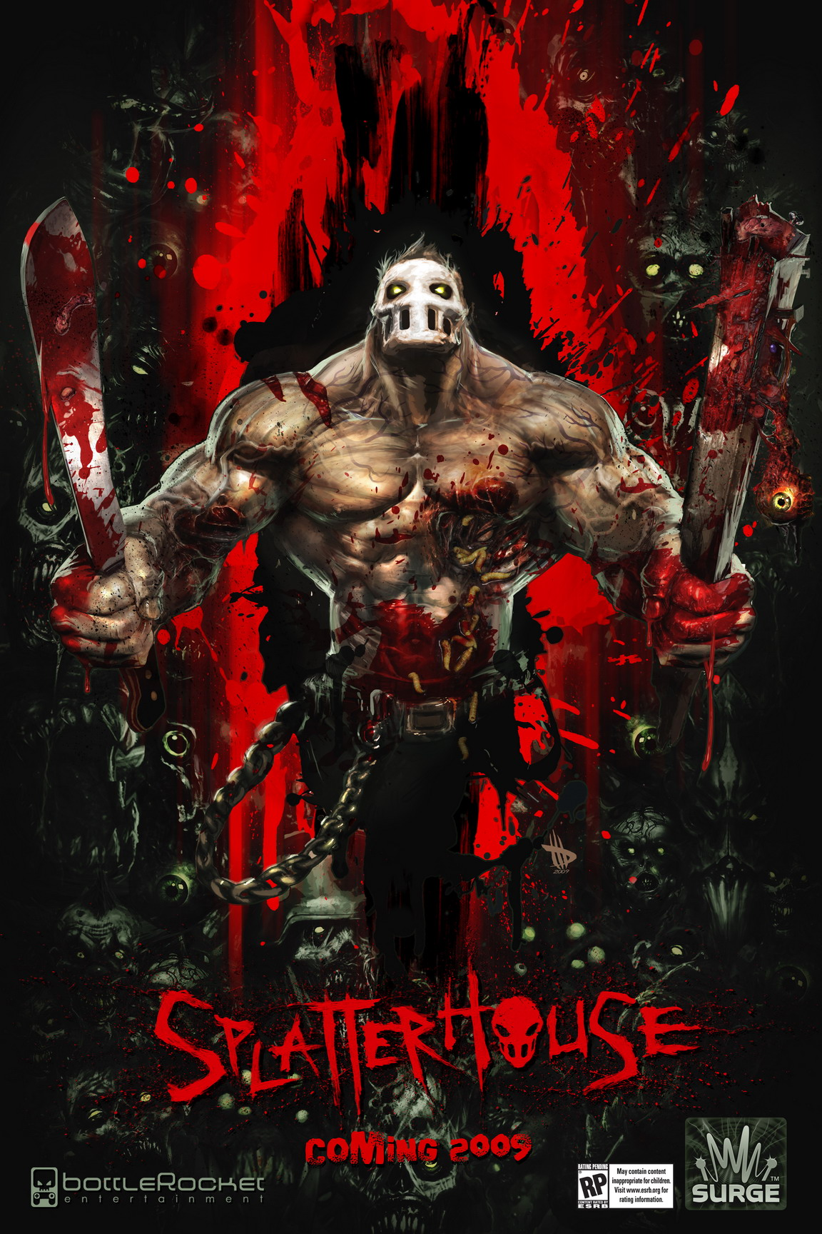

GAME DESIGN DOC v2.1 (ALPHA)

Intro 3
This Document 3
Philosophy and Mood 3
Common Questions 3
Key Features 5
Setting 6
Plot Synopsis 6
Characters 8
Monsters 9
Locations 9
Game Overview 12
Game Structure 12
General Play Mechanics 12
Story 15
Game Mechanics 16
Camera 16
Navigation 18
Player Attributes 18
Leveling Up 19
Secrets & Collectibles 20
Mini Games 20
Combat Mechanics 22
Selection System 22
Basic Combat 23
Modal Combat 25
Weapons 26
Player Death 28
Enemies 29
Zombies 29
The Corrupted Army 31
Sub-Bosses 35
Bosses 36
Large Bosses 39
Enemy Generation 46
User Interface 47
Menus 47
HUD 48
Levels 49
General Level Format 49
Environments 49
Level Walkthroughs 49
Musical Score and Sound Effects 53
Sound Effects 53
Music 53
Cinematics 56
Conclusion 58

Intro

This Document
This document describes the game design by BottleRocket Entertainment on the Splatterhouse Game Concept for PS3 and Xbox360. This is a high level concept of the game, with thought put into gameplay mechanics, world design, characters, animation, and production. This document refers to the Xbox360 controller; however gameplay, philosophy, and controls are being designed to be universal across both platforms.

The following abbreviations will occasionally be used.

- AOE: an Area of Effect attack; any sort of attack that hits opponents located within a certain radial range of the character.
- Necro: Necrotic energy; the type of energy Rick collects in the game

Philosophy and Mood
When approaching game design, we feel that it is best to first define a philosophy and a mood that we are attempting to create. In the case of Splatterhouse, we are attempting to create the kind of mood and emotions one might experience when seeing a horror movie, more specifically one made by Sam Raimi or Peter Jackson. In Splatterhouse, there will be cases of extreme gore and heart stopping scares all centered on a character that is an unstoppable machine of death and destruction.

- Extreme Gore
  - Violent regeneration
  - Enemies treated like sacks of blood and guts
- Heart Stopping Scares
  - Unexpected surprises
  - Intense pacing and situations
- Bad Ass Factor
  - Brutish strength
  - Regeneration

Common Questions

What is the game?
Splatterhouse is a 3rd person action adventure title with horror thematic elements in the vein of Devil May Cry and Dead Rising that touches upon the rampaging and carnage found in Hulk: Ultimate Destruction.

Why create this game?
Namco wishes to create a next generation version of the beloved title that will renew player interest and reestablish it as a viable and lucrative franchise.

Where does the game take place?
The core of the game play takes place in a spooky gothic mansion overrun by Corrupted denizens. By traveling through various portals the player will find himself in locations scattered through space and time allowing the player to be in an Arctic Military Base one moment and then an Abandoned Carnival the next.

What do I control?
You control Rick, a hulking brute merged with an ancient mask of indescribable power that transformed him from a skinny college kid to a ferocious being of limitless brutality. This mask transforms Rick into a monstrosity capable of tearing enemies apart with his bare hands and regenerating from just about any wound, thus making him a nigh unstoppable powerhouse.

How many characters do I control?
The player controls the game’s hero, Rick.

What is the main focus?
The focus of this game is to slaughter your way through time and space on a quest to save your kidnapped girlfriend.

What’s different?
Regeneration - Many games allow the main character to restore health over time, but this is always just done as a HUD element (e.g. the characters health bar just refills). We are taking a next generation approach to this by actually showing the character of Rick getting damaged, with chunks of body being torn out or his limbs being removed. Then as he starts to heal, the missing parts of his body will grow back in real time. Players will actually see an arm sprout bone and get covered with muscle and sinew before finally growing the epidermal layer.

Realistic Gore - As mentioned above, when the player and creatures take damage, it won’t just be some blood particle effects. Flesh will be torn, guts will be spilled, limbs will be broken and removed. By taking advantage of our physics system, players and monsters alike will act and respond like “fleshy sacks of blood and guts”. Hit something hard enough and it’s going to explode like a ripe watermelon or a water balloon with viscous fluid and internal organs being expunged from the trauma.

Dynamic Combat System - In previous BottleRocket games, the combat was designed to feel more like a cinematic sword fight. An enemy would lunge in, the player would block and do his own counter attack, and the rest of the enemies would wait around until it was their turn. This time around, the Corrupted hordes of the abyss aren’t wasting any time, and will be doing their best to overwhelm Rick. The player will now be able to take on large groups of opponents at one time, using them against each other. And even if he does get overwhelmed and the enemies all pile on top of him, Rick still has a few surprises up his sleeve to deal with them.

Key Features

Fast-Paced Strategic Combat
- Deep set of moves and abilities
- Improvised weapons
- Two different combat modes

Extreme Gore
- Most stunning and shocking gore ever seen in a game by utilizing a combination of hand animation and physical simulations.

Dismemberment
- Rick will be able to rip body parts from his enemies and use them as weapons.

Regeneration
- The power of Rick’s mask regenerates his injuries, even his lost limbs, making him nearly unstoppable.
- Fleshy, messy, painful regeneration in full real-time 3D

Modal Combat
- Control Rick in two different modes: Brawler and Berserker.
- Improvise weapons and use your enemies against each other in Brawler mode.
- Demolish your enemies with the overwhelming power and momentum of your rage in Berserker mode.

Environmental Destruction
- Destruction of environmental objects using Havok physics to convey Rick’s power and ferocity.

Weapons
- Rick will have the ability to use weapons he finds in his environment.
- Create weapons from enemies by ripping off their limbs and heads.

Epic Bosses
- Gargantuan boss characters whose sheer scale will make them a memorable and impactful gameplay experience.

Portals
- Corrupted gateways that will take Rick to a broad variety of terrifying locations in space and time.
- Pursue evil all over the world and throughout history.

Setting

Plot Synopsis

Brief Summary
Rick arrives at West Mansion with Jennifer. She's been invited to write a story on Dr. West for the school newspaper. Rick has come along because he doesn't like the idea of his girl being here at the home of creepy old Doctor West. Arriving at the mansion, there is a large portrait of (what we assume to be) one of West's ancestors in period dress with a woman who looks strikingly like Jennifer. While all this is going on, we see Rick secretly looking at something he’s taken out his pocket – a box with an engagement ring in it. He’s nervous, waiting for the right time and place to pop the question to Jennifer (here in creepy old West Manor clearly isn’t it…) but he tries to steer the conversation around to his plans for a romantic dinner tonight (where he’s obviously going to propose to Jennifer) after the rock concert that they’ve got tickets to . [The concert is using the total solar eclipse as a gimmick – it’s called ‘Darkside’, or something equally goofy, but we still get to slip reference to the imminent eclipse early into the story…] West appears, breaking the mood. He’s irritated that Rick is here and uninvited. He makes a grab for her. Rick moves to stop him....and is shockingly attacked by one of West's pet creatures. In front of Jennifer's horrified gaze, the thing guts Rick. Rick falls dying to the floor. His last sight is of West dragging off a screaming and helpless Jennifer. Then they're gone, and he's left alone to die.

And then, in the last few moments of his life, he hears the voice of the Terror Mask talking to him, cajoling him and promising him a means of revenge and a way of getting his girl back. He looks at a photo of Jennifer lying on the ground in front of him – that’s all the motivation he needs. With the last of his strength., he puts the Mask on, and the game begins.

Rick puts on the Mask, and, with the strength and supernatural abilities that gives him, is able to go after West and try to save Jennifer. He catches up with West at the end of Level 1, but loses him when West vanishes into the portal. Rick follows and is transported to the Thule Archipelago, but arriving quite significantly later than West. Thereafter, Rick is playing catch-up with West, following his trail through the game levels, a trail that will ultimately lead him to the final Place of Sacrifice, where the last elements of the gateway opening ritual will be enacted.

To accomplish that, West has to visit various Corrupted-affected places of power on Earth, areas special or sacred to The Corrupted and their followers. These are places in each of the locales accessed through the portal in West Manor – the Thule Archipelago, the Third World Shanty Town and Carnival, the Doppler Brothers Carnival and the Antarctic Base. At each of these places, West has to conduct some brief kind of ritual to ‘activate’ the occult power of these places, harnessing it to finally open the gateway back at West Manor. Rick will catch sight of West at various points, or may find clues that Jennifer has resourcefully managed to leave behind, but West will always manage to slip away in time, elusively remaining just one step ahead of Rick. The Corrupted servants that inhabit these places, forewarned by West that Rick is following on behind, will do everything to stop Rick’s pursuit of West.

The Terror Mask quickly figures out what West’s plan is, although it might not initially share the full knowledge of this with Rick, who it sees as an annoying little insect that stubbornly refuses to succumb to the inevitable and allow the Mask entity to completely take it over body and soul. Since Rick has proved stronger than the Mask has expected, it’s forced into co-operating with him, pretending that all it wants to do his help him get his girl back, but really just wanting some payback on the rest of The Corrupted, and especially its Overlord father. It’ll soon become obvious to Rick and the player that the Mask entity has some kind of serious grudge against the forces they’re fighting, but some of the truth about it will only come out through the course of the game, and the Mask only really shows its true colors and “this world is mine, and no-one else is getting it” plan at the very end, when Rick confronts the Overlord as Body Boss.

Characters
The following are the characters of Splatterhouse, including enemy and boss characters. Further character details can be found in separate fiction documentation.

Rick
The hero of the game, Rick is a slight college student who, desperate to save his girlfriend Jennifer, dons a Corrupted mask he finds in the West manor, becoming a hulking brute with supernatural powers; suddenly he finds himself capable of taking great damage, regenerating lost limbs, and ripping monsters apart with his bare hands.

With the mask, Rick can also turn into a berserker, becoming an embodiment of his rage. As a berserker Rick has enhanced strength and the ability to wipe out greater groups of enemies.

Rick’s modes and abilities are outlined in the section on game mechanics in this document.

Jennifer
Jennifer is the love of Rick’s life, his girlfriend of many years and the most important person in the world to him. Beyond angelic in her beauty and disposition, Jennifer was courted by many men who were more rich, powerful, or handsome than Rick, but she rejected them all for him because of the deep bond they share. He would do anything for her, and she for him. Upon arriving at West Manor, she is kidnapped by Dr. West for his nefarious purposes. Desperate to save Jennifer, Rick succumbs to the mask’s temptations of power, donning it to rescue her. Saving her is the ultimate goal of Splatterhouse.

The Mask
The mask is the source of Rick’s power. It is originally from The Abyss, the dimension where the Corrupted reign. The mask is sentient and will guide Rick throughout the game, but his guidance will be manipulative and self-serving, as Rick will ultimately discover.

The mask is permanent to Rick once he puts it on: when he places it on its face, it grafts itself onto him, parasitically integrating itself. It grants Rick all of his supernatural powers, near invulnerability, regeneration, and supernatural strength, and is perennial to the gameplay.

Corrupted Overlord
This character is in charge of the Abyss, which is the origin of the Mask and the Corrupted Horde. During Rick’s final confrontation with the Overlord, it will use its power to raise a legion of corpses and combine them to create a towering golem of corpses. He is essentially the father of the entity bound in the mask.

Dr. West
A legendary parapsychologist, Dr. West has descended into madness and has been experimenting with re-animating Corrupted creatures. He kidnaps Jennifer and is Rick’s primary nemesis, taunting him throughout the game. Dr. West is responsible for rediscovering the mask and opening portals to other dimensions. Most of the game’s backstory is told through pages from Dr. West’s lost journal, each of which contains a brief exposition of some of the storyline.

Monsters
The following is a list of the enemies of Splatterhouse. Each enemy is designed to be tactically significant, and this list illustrates the kind of strategies and elements that will form the Splatterhouse gameplay. More detail about them can be found in the Combat Mechanics: Enemies section.

Foot Soldier – This is a basic enemy that comes in a variety of forms, and will become tougher over the course of the game.

Foot Soldier Sentinel – This is a modified version of the footsoldier whose primary role is to alert other enemies to Rick’s presence. He shares the same toughness progression chart as the footsoldier.

Aggressor – This is an enemy who makes other enemies go into a frenzy, making them stronger, faster, and more ferocious.

Summoner – This is an enemy who creates portals, summoning more enemies into the room.

Spitter – This is a enemy with a ranged attack who acts like a turret. He will explode if damaged or if the player gets too close. His projectile is a leech like creature which can turn into a Bloater.

Leech – This is an enemy fired from a Spitter who can latch itself onto Rick and begin to suck off his Necro energy. Not only does the leech prevent Rick from going berserk by sapping Necro, but when it has siphoned off enough, it pops off Rick and undergoes a metamorphosis into the more threatening Bloater enemy.

Bloater – This is an enemy that will explode if it gets too close to Rick.

Zombies – Each level has its own unique zombies. Although these are all basically the same enemy, some zombies will have unique abilities and attacks, and can carry weapons.

Locations
The following is a list of the Splatterhouse environments. These sample environments definitely show the range and variety of unique and thrilling locales that will make Splatterhouse a compelling next-gen experience.

The West Manor
This signature house of horror from the original title serves as the hub location for the game, containing Dr. West’s twisted labs along with the dimensional portals that Rick must explore. The mansion is vast, labyrinthine, gothic, and horrifying, juxtaposing massive libraries and abandoned dining rooms with brutal cesspools of torture and occult experimentation. Parts of the mansion are closed off at different points in the game and become available as the player progresses.

Mansion Estate
The West Manor is not just a house, but also an estate: therefore, the player will also have to traverse the grounds of the manor. The first accessible area is the Manor Gardens, a once finely pruned landscape now overgrown with neglect and decay. The fog-shrouded terrain of the manor’s Estate hides patrolling Wickermen looking for easy prey. Further on is the graveyard of the West family. Beyond the graveyard lies a mysterious sacrificial altar on a spit of land overlooking an expansive sea.

Portals
Though not a distinct environment in and of themselves, the Corrupted portals in the West manor will be an important element in the player’s environment, serving as the most important landmarks in the game and as a key objective for the player. These portals will teleport Rick to wildly different locations and periods of history that contain key events in the overarching fiction.

Portal Locations
The following are the portal locations that Rick will explore.

Slaughterhouse
In a dark part of our globe, a group of primitive humans are being systematically slaughtered and processed by the Corrupted army, who has built an enormous slaughterhouse in the center of an impoverished shanty town. Morlocks have been snatching these “Innocents” from their homes and bringing them to the slaughter for decades. Rick will need to battle his way through the crumbling shanties to reach the highest floor of the Slaughterhouse where Biggie Man awaits...

Arctic
One portal leads to a former military base that has been partially excavated by soldiers who were trying to access its unimaginable arcane power. Zombified by an ancient dark energy leaking from the portal, the soldiers now mindlessly guard the goal of their original mission: to use the portal energy to power an unstoppable military weapon. Rick must destroy the base’s inhabitants, face the RoboApe Boss and return to the Manor alive.

Abandoned Carnival
An old time Carnival had the misfortune of being built on top of a Corrupted temple, and so was utterly cursed from its inception. The carnival was only open to the public for a day: it was shut down promptly after a series of grim freak accidents. Rick must battle through the narrows of a seemingly deserted midway, overcome his fear of clowns (by beating them to death), to reach the Hall of Mirrors where Mirror Rick awaits…

Islands
Rick has been transported to The Thule Lord’s Nest, an archipelago of Islands surrounding a massive, ravenous Thule Lord. The stone statues on the islands hold the key to destroying The Thule Lord, and Rick must travel from island to island realigning the stones to awaken The Thule Lord from the depths. Rick must then fire these mystically charged stones at The Thule Lord to destroy it while avoiding The Thule Lord’s vicious attacks.

Environment Table

The following table indexes the basic “feel” of each environment. For each environment we have included reference to the pages in the Splatterhouse Visual Reference Book, several copies of which have been provided to Namco, for a collage of visual concept reference.

Time of Day Chart
Environment | Inside/Outside | Area Type | Time of Day | Visual Reference Pages
Manor Interior | Inside | Open Space, hallways, small rooms | Lit rooms, night outside | 2-6
Thule Islands | Outside | Open Space, broken down structures | Stormy weather, day | 24-29
Manor – Estate & Interior | Both | Open Space, hallways, small rooms, mansion estate | Lit rooms, night outside | 6,13
Slaughterhouse | Both | Outdoor Alleyways, Factory floors | Cloudy, day | 30-35
Manor – Estate & Interior | Both | Open Space, hallways, small rooms, mansion estate | Lit rooms, night outside | 7-11
Carnival | Both | Midway, open space, hall of mirrors | Foggy, night | 36-44
Arctic Base | Both | Corridors, industrial | Daytime | 46-55
Manor – Estate | Both | Mansion estate, sacrificial area | Morning & Eclipse | 7-11

Game Overview

Game Structure
- Kill creatures to collect Necro
- Gain upgrades for your abilities and use necro energy to activate berserker mode
- The player’s overall objective is to rescue his girlfriend Jennifer from the clutches of Dr. West
- The player will travel through a main portal in the mansion to reach new areas
- The player must battle through these areas discovering clues to Dr West’s plans
- Once Rick has completely the main missions and discovered West’s plans he is ready for a final confrontation with West and the Corrupted Overlord.

General Play Mechanics

Navigation
Players control Rick’s basic navigation using the left analog stick. Rick also various jump abilities, including a standard jump and homing jumps onto “travel nodes” located throughout his environment.

Basic Combat
The game’s combat combines a deep combo system, grappling gameplay, and a robust targeting and selection system that allows the player to attack in any direction using a combat system built and tuned using familiar gameplay touchstones with a Bottlerocket flair.
Players are able to defend against most attacks by simply pressing and holding the block button. Similar to the disarm system used in Mark of Kri, if the player times the pressing of this button to exactly when being attacked, he can pull off a counter move which in most cases will allow the player to grab his opponent or perform another predefined counterattack.
Grabbing an enemy (via counter, combo or button press) allows Rick to perform particularly devastating moves. He can remove limbs and turn them into weapons, pummel enemies to intimidate other enemies and generate increased necro, throw enemies into other enemies or walls(effectively turning them into projectiles), and body slam enemies by leaping with them into the air and slamming them into the ground, creating a shockwave that damages nearby enemies.

Splatter Kills are special finishing moves that the player can pull off on certain enemies when they are low on health. Similarly, Splatter Moves are special attack moves the player can pull off on certain enemies after successfully completing a combat based mini game.

Also, throughout the game, Rick will find weapons in his environment, such as shotguns, chainsaws, cleavers, cinderblocks and lead pipes. Rick will be able to pick these weapons up to augment his combat abilities, making him even more deadly. Each weapon will only last for a short period of time, acting as a temporary powerup. Some weapons are specifically designed to be thrown, giving Rick a one time projectile attack.

Summary of Splatterkills and Splattermoves

Boss Splatterkills
- Clawface Splattermove - leap onto back and punch head
- Clawface Splatterkill - leap onto back and punch out brain pan
- Biggie Splatterkill – Has two splatterkills. The first, the player picks up a woozy Biggy, cut to cinematic of the player throwing biggie into the corrupted portal. The second splatterkill is when you fight him in level 9. It is a chainsaw reverse of Biggie attacking rick, with Rick grabbing the chainsaw and shoving it into Biggie’s chest killing him.
- RoboApe Splattermove - jump up and push pin into RoboApe head
- RoboApe Splatterkill - jump up and push final pin into RoboApe head
- Aggressor Splatterkill – Rick jumps on top of Aggressor grabbing him by the horns and twisting them, decapitating his head, then stabbing him in the chest with the dismembered Aggressor head.
- Summoner Splatterkill – Rick jumps of the summoner’s back and tears off his head, and squishes it in his fist.

Enemy Splatterkills (work on Morlock, Zombie, Footsoldier)
- Arm Removal - take off arm
- Head Removal - take off head
- Arm Breaker - snap arm
- Punch Flurry - rapid punches to stomach/head exploding the character.
- Side to Side Slam - lift up enemy and slam him down on either aide of Rick
- Vader Choke - lift up enemy and do Darth Vader choke out
- Launch and Super Punch - toss enemy up and super punch them away
- Neck Break - snap/twist enemy necks
- Back Breaker - slam enemy down on Rick’s back and break enemy back
- Horizontal Tear - rip enemy in half
- MultiSmash - Grabbing the enemies by the feet, smashing him on the ground multiple times first popping his head, the exploding his body.
- Head Pop - slap off the head of an enemy
- Curb Stomp - smash enemy head off
- Pile Driver - wrestling move - piledriver

Weapon Splatterkills (work on Morlock, Zombie, Footsoldier)
- Blunt Weapon (2x4, etc) – Similar to the toss in air super punch, Rick bats the NPC in the air, jumps up and swats them down to the ground.
- Bladed Weapon (swords, etc) – Rick tosses his weapon up in the air, catches it and in one swift move impales the face of the NPC with his blade.
- Chainsaw – Rick takes his time and saws each arm off, then slowly separates the upper and lower half of the enemy.
- Shotgun - blow off enemy head by sticking shotgun in mouth of enemy

Non-Combat Gameplay
There are other gameplay elements outside of the game’s combat. The most basic of which is platforming: Rick will have to negotiate various environmental obstacles using directed leaps towards jump nodes, which will vastly expand on the challenging opportunities for environmental gameplay.

There will also be some puzzle solving elements in the form of mini-games (ie.“simon says”, feat-of-strength) and Necro objects (charge stones and portal stones.) Rick will have to use his Necro energy correctly to activate these objects before using them.

Downloadable Content
The following is the proposal for the first downloadable content pack for Splatterhouse.
This is identified as one of the biggest risks to development. As such, it is still being discussed between Namco and BR.

Additional Levels
We are proposing 6 arena-sized levels which are re-workings of existing levels. These levels are essentially large scale battles with pre-defined waves of enemies.

Of interest to the player is how we will be mixing up the enemy types from the single player game when we re-envision the levels. Wickerman will now be found on the Thule Isles, RoboApes will be found in the Shantytown, etc. We will also be scattering new weapon types throughout the challenges for the player to discover and use.

The fiction behind these levels is the Terror Mask testing Rick. It generates a series of challenges based on Rick’s worst nightmares/battles. Rick will mini portal to each environment and find himself in a contained area against a group of enemies he must defeat to move on.

- Secret Area (Final Battle Area)– This is the final area of the game reworked for DLC gameplay
- Thule Islands – Island 1-4 reworked for DLC gameplay
- Mansion Lab – Lab area reworked for DLC gameplay
- Carnival Midway – A section of the Carnival reworked for DLC gameplay
- Entrance to Slaughterhouse – the front area of the Slaughterhouse reworked for DLC gameplay
- Mansion Gardens – the mansion garden area reworked for DLC gameplay

Jennifer Zombie Character
We will be adding a new Jennifer Zombie which you will fight in the last arena you visit. She will be based off the current zombie skeleton and share a set of animations from the zombie class but she will be given unique abilities to make her into a formable boss. Exact powers TBD but the following are examples of possible attributes:
- Summon Zombies/Morlocks
- Projectile Attack
- Summon Mirror Rick
- Unique Splatterkills
- Area of effect attacks
- Movement and attack variations from regular zombie class

New Splatterkills
New Splatterkills will be created for the DLC. These would be available throughout the single player game as well as the DLC levels.
- A set of 4 new Splatterkills with new animations sets.
  - 2 Punch based Splatterkills
  - 2 Kick based Splatterkills

New Weapons Pack
A set of weapons/objects from Dr West’s mansion are now scattered about the DLC levels for you to find. These are only available in the DLC levels.
- Battery – a car battery. Causes a stun in any enemy it‘s thrown at - projectile weapon
- Pipe wrapped with barbed wires – blunt weapon - extra damage.
- West Family Scimitar – curved bladed weapon doing extra slashing damage.
- West’s Hunting Rifle – Similar to the shotgun but does high damage to a single target and no splash damage

Retailer Specific Content
This is a list of retailer specific content – these would be user activated with a code and shipped with the game. Each can be tied to a specific retailer:
- Spiked Club – Replaces 2x4
- Samurai Sword – Replaces sword
- Hedge Trimmer – Replaces Chainsaw
- Bowling Ball – Replaces Cinderblock
- (broken) Halberd – Replaces Sword

Story
Throughout the game, story elements will be revealed to the player through three avenues: cut scenes, audio exposition from the mask, and pages from Dr. West’s journal.

Cut Scenes
The purpose of an in-game cut scene is to more fully set the stage and mood of a particular level. Cut scenes can help to give a player a sense of purpose throughout a level, as well provide clues for their objectives.

The Mask
As a sentient being with extensive knowledge of the workings of the world of Splatterhouse, the Mask is an excellent avenue for hints and story information. The Mask also provides us with an opportunity to deliver information to the player without breaking gameplay as the Mask can narrate at any time. There is also the potential for an interesting “odd couple” relationship to develop through dialogue between the Mask and Rick.

Dr. West’s Journal
Deeper moments of storytelling will be conveyed through the pages of Dr. West’s journal. These will be mostly text with images and diagrams accompanying the writing. Most of the pages will be automatically found by Rick at the beginning and end of levels. These cut scenes will be used to disguise loads and further the story in between gameplay. Other pages will be secret pages hidden throughout the game that the player must discover. These pages will tell secondary story elements and some of the deeper elements of the backstory.

The player will be able to review the pages of the journal that they have found via the Main Menu.

Game Mechanics

Camera

Overview
The cameras in Splatterhouse are designed to provide the best possible view of gameplay at all times. Splatterhouse makes use of the following cameras:

- User Controlled Camera
- Focus Lock Camera
- Environment Camera
- "Golden Moment" Camera
- Jump Node Camera

Creative implementation and use of these camera systems will deliver the best of both worlds: an up-close and personal feel for combat and a vast and epic feel for our environments.

User Controlled Camera
The user controlled camera is activated by moving the Right Analog Stick (RAS). Movement of the RAS will allow the user to look up and down in 360 degrees about the environment. This camera will the primary camera used in the game.

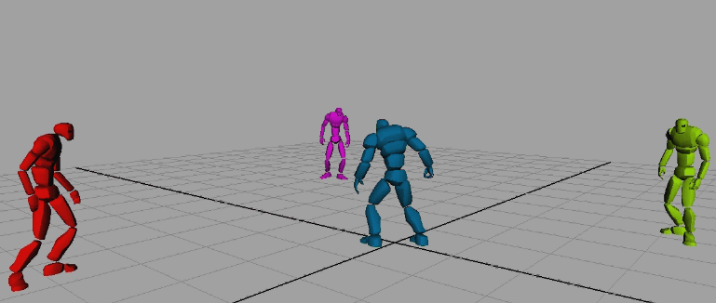
Combat Camera (Fig 1.0)

Focus Lock Camera
A camera positioned behind the player will be used when player is focused locked on an enemy. Camera facing and depth of field will be used to indicate the user’s target selection.

Environment Camera
The Environment camera will be a very scripted camera that will work off a zone type system. This is going to be prototyped by the programmers with feedback received from Art and Design regarding setup and implementation. The concept is that based around that the camera will execute specific paths and behaviors depending on the zone the player is currently in. The camera would follow pre-assigned paths and stationary look points through the environments. Additional points of interest would be triggered to be included in the view along with the mood for the area.

Below is an example of how the rail camera might work.
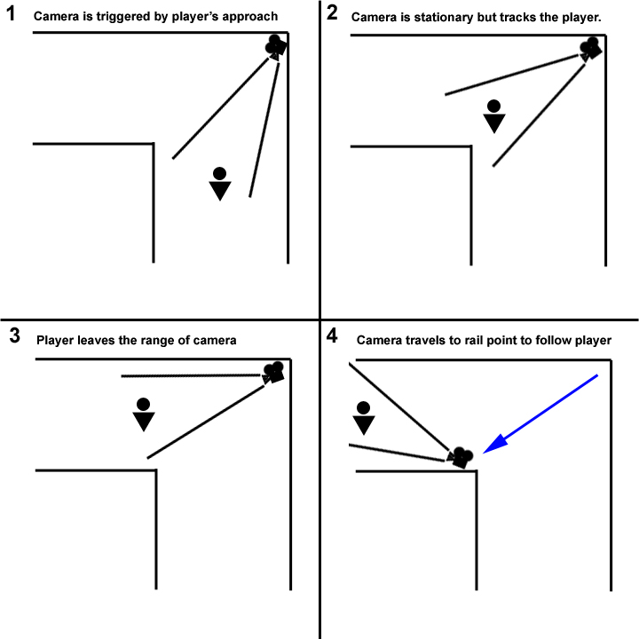

The environmental camera may also be used for specific vista points. Vista points are moment in a level where the game will highlight a particular aspect of a level using camera work to emphasize a focus for the player.

“Golden Moment" Camera
"Golden Moment" cameras will be used to highlight particularly cinematic moments such as Splatterkills, Boss deaths, or Rick deaths.

Jump Node Camera
This camera gives you a better view of your jump node path.

Navigation

Basic Navigation
Rick’s basic navigation abilities begin with the basic running and walking of all third person action games. Rick can also perform a normal jump and jump between jump travel nodes.

Jump Nodes
Jump nodes are points in the environment that Rick can quickly and automatically leap to and hang from. In this way, they are very similar to grappling hook points, as seen in God of War 2 or Metroid Prime. Jump nodes are made visible to the player with a slight glint or aura that surrounds them. When the player is within activation range of a jump node, the glint or aura becomes noticeably brighter. Rick will automatically home in on a jump node by facing it and jumping towards it. A jump node leap can be longer than a regular jump.

For additional challenge, some jump nodes may move, others may activate and deactivate, and some may collapse after Rick has been on them for a moment.

Navigation Nodes
- Navigation nodes do not allow the carrying of weapons across them
- You can travel from one navigation node to another navigation node
- Enemies do not travel on navigation nodes
- Navigation nodes can have special properties (collapse, timed activation, etc)

Player Attributes
Rick has three main attributes:
- Health
  - This is the amount of damage Rick can take before dying.
  - His health can slowly regenerate, but it can be depleted, which will kill Rick.
- Necrotic Energy
  - This is the amount of Necro energy that Rick can hold at any time. Necro is used to activate Berserker mode and trigger environmental objects.
- Combat Abilities
  - As the player progresses through the levels he is given additional combat abilities, making Rick even more devastating.

Necrotic Energy
Necro energy is collected every time you kill or severely damage an enemy. The brutality of the damage is commensurate with the amount of Necro received. Particularly damaging moves, splatterkills, and pummel are ways to increase the amount of Necro the player receives.

Necro energy is what Rick uses to activate his Berserker ability: Necro is required to enrage Rick into Berserker and is the fuel which keeps it going. The onscreen Necro meter is notched into segments, with each segment representing one triggering of berserker mode.

Necro energy is also used to for Necrotic objects, special objects in the world that require necro energy to be activated. The player must discharge some of his own necro energy into the object before it can be used.

The following is a list of some necrotic objects in the game.
- Charge stones
- Portal stones

Leveling Up
Leveling up in Splatterhouse is done via two systems. The first system is the Necro Rewards system. The overarching theme of the game is the more brutal the kill, the more necro the player will gain. The game keeps track of the total necro collected by the player. At the end of each Act, a rewards screen is presented. If the player reaches certain necro thresholds, they will be rewarded with necro capacity increases and unlocking of Splatterkills, as outlined below.

Necro Threshold | Reward
0 | Arm Breaker
0 | Vader Choke
0 | Back Breaker
0 | Head Pop
625 | Necro Capacity Upgrade 1
1250 | Punch Flurry
1850 | Side to Side Slam
2475 | Super Punch
3100 | Head Removal
3700 | Necro Capacity Upgrade 2
4300 | Neck Break
5000 | Horizontal Tear
5550 | Multi-smash
6200 | Necro Capacity Upgrade 3
6800 | Arm Pull
7400 | Curb Stomp
8000 | Pile Driver
8650 | Necro Capacity Upgrade 4

The second system for leveling up is related to Rick’s combat abilities. Rick will start the game with a subset of his combat abilities and gradually unlock them based on game progress (not based on necro collection.) For example, Rick may start the game with 2-hit combos. After reaching a certain part of a level, the player will be alerted via tutorial text that they have unlocked 3-hit combos. Other aspects of Rick’s combat abilities will be treated similarly. The unlocking of Rick’s combat abilities is a recent improvement to the game – a definitive chart will be coming soon.

Secrets & Collectibles
Certain destructible objects or hidden locations within the levels contain a secret power up or collectible. These secrets range from a Necro energy boost, a hidden weapon, a page from Dr. West’s journal, or a photo of Jennifer. Missing these items will not be detrimental to the overall gameplay - they are simply there to give attentive players an extra bonus for thoroughly exploring the game.

Dr West’s Secret Journal Pages
Although the main plot points of the story will be related to the player through journal entries that are automatically given at the start of a level, certain journal pages will require the player to maintain a watchful eye to find. These secret journal pages will add significant re-playability to the game, spark discussion and speculation in the gaming community, as well as providing an avenue for deeper and more detailed storytelling.

Secret Photos from Jennifer
Jennifer has left a trail of breadcrumbs for Rick to follow in the form of photos. These photos are rare secrets (about one per level) and are intended to be the hardest to find (similar to the Skulls in Halo 3.) Not only do they photos provide bragging rights for the players who find them, but the content of the photos also provide entertainment for the player as each photo depicts Jennifer in various states of undress.

Combat Mechanics

Selection System
Soft Lock
Soft lock is used by navigating Rick towards the enemies and pressing any attack button. Rick will use a soft lock mechanic to select the closest and most appropriate enemy and attempt to remain locked (within set parameters) to the chosen target. The idea is to keep the player tracking the chosen enemy and allow the combo chain to continue uninterrupted. Significant changes to the target (like attacking an enemy behind Rick) will cause the soft selection to reset the current combo chain.

Focus Lock
Focus lock allows the player to focus Rick’s attacks on a single enemy or part of a giant enemy. By holding the lock button the player will select the nearest character directly in front of him, indicated by a rim light (white if enemy is healthy, red if they are at low health.) Once this character is selected Rick will orbit around the selected enemy. Rick can change selection in this mode by moving the Right Analog Stick.

Basic Combat

Combos
Similar to the combos found in other action games, but with BottleRocket’s distinctive and fluid style, combos are structured as three button presses - an initial attack followed by a series of modifiers - although longer combos can be created by chaining in grabs and Splatterkills.

Blocking
By holding down the “block” button, Rick will be able to block all incoming attacks from any direction.

Countering
By timing a block correctly, Rick will counter the enemy’s attack, putting them in a grapple state.

Grabbing
This button will initiate a grab attempt on valid enemies. This can be done via a counter and certain combo moves also. Successful grabs end in the Grappling state.

Grappling
The player has a consistent set of options from any grapple: they can perform a throw, a pummel, or a body slam. Each of these moves is mapped to a face button contextual to the grapple state.

Throw
To throw a grappled enemy, the player simply needs to point the left stick in any direction and press the B button. The enemy will be thrown in that direction, impacting against a wall, colliding with other enemies, of being thrown over a cliff.

Body Slam
The player can choose to initiate a body slam by pressing the A button with a grappled enemy. This will cause Rick to leap into the air with his grappled enemy in tow, and then slam them back into the ground, doing massive damage to the enemy and creating an area of effect attack, damaging any nearby enemies.

Pummel
When the player has an enemy in a grapple state, they can repeatedly press the X or Y button to pummel their captured enemy. This sadistic move allows the player to gain extra Necro energy while causing significant damage to the enemy.

Throwing
Besides throwing grabbed enemies, Rick can also use projectile weapons to take out long distance enemies. For more information on thrown weapons, please refer to the Weapons section of this document.

Limb Removal
Limb Removal becomes available when the player unlocks Head and Arm pull Splatterkills. The arms and heads of footsoldiers, sentinels, all zombies, and morlocks can be weaponized via these splatterkills.

Splatter Kill
When the player gets an enemy down to a certain level of health he will be able to initiate a Splatterkill. This is a particularly gruesome kill with Rick brutalizing his enemy by doing one of the most spectacularly over the top kills in the game. The Splatterkill is initiated by grabbing an enemy who is at low health (indicated by a red rim highlight) and hitting a short series of buttons to activate the intended Splatterkill.

Body Explosion
If Rick is taken to the ground by certain enemies, nearby enemies will join in and dog pile Rick, attempting to subdue him.

At this point, players must use Rick’s body explosion ability: successfully performing the commands in a short mini-game will cause Rick to forcefully burst from underneath the dog pile, sending his enemies flying through the air. If the player fails to complete the mini-game, the dog pile will subdue Rick and he will die.

Body Fountain
As a visually spectacular element of Rick’s Berserker mode, his charges will send his enemies flying in all directions with procedural rag doll physics, creating a fountain of bodies in his wake. We feel that this effect will distinctly reinforce berserker Rick’s unstoppable power.

Regeneration
The Mask endows Rick with the supernatural ability to regenerate himself. As Rick is damaged in combat, this damage will be reflected in actual, physical damage to the character. At first he will receive superficial wounds. Then his torso will be ravaged, showing his ribs and internal organs. Specific enemy attacks will result in Rick losing an arm. The loss of each arm progressively limits Rick’s abilities. When Rick loses his right arm, he loses the ability to counter, perform punch combos, grab (and thus grab actions and Splatterkills) and the use of weapons. When Rick loses his left arm, he can no longer use travel jump nodes. If Rick loses both arms, it is best for the player to simply run away and recover.

If Rick can avoid damage and combat for a short period of time, he will begin to regenerate the damage done to him, including any lost limbs. This will be fully reflected on the character as a next-gen graphical effect.

Modal Combat
Rick can be in two different modes, Brawler or Berserker, and with each mode a different set of abilities, moves, and strategies becomes available. The following is a summary of his modes.

Brawler
Rick’s Brawler mode can be thought of as a hybrid mode, allowing the player to either focus on a single enemy or take on multiple foes at once with more lateral attacks. Brawler Rick also has the deepest set of combos, and is the most adept at manipulating his enemies and using them against each other. Moves in this mode will consist of powerful melee attacks, deep combos, and using enemies against each other by throwing them or utilizing their body parts.

Players are also able to use improvised weapons in this mode, either picked up from their environment or ripped off of enemies, both as melee weapons and as thrown objects. Players who use Brawler mode must have a flexible strategy, using a broad range of abilities to deal with a variety of situations.

Brawler Rick’s combat style can be likened to the Mr. Hyde character in the Van Helsing film. The centerpiece of his combat style is his powerful hand to hand combos, his grapple moves, and using enemies against each other.

Berserker
Rick’s Berserker mode is centered on crazed, heavy damage against masses of enemies. This is Rick’s most powerful mode and is utilized to eliminate multiple enemies quickly. He is able to use the same move and attack set that he has in Brawler mode, but with God-like fury and strength. When Rick turns Berserk, he releases a large pulse of Necro energy which will send enemies in his general vicinity flying in all directions. The residual Necro from this release will super charge Rick, amping up the amount of damage that Rick will do with each of his individual attacks. Plus the residual Necro will fully heal Rick and make him invulnerable for a short amount of time.

Weapons
In adhering to the overall theme of Splatterhouse and to put the emphasis on Rick’s ability to tear his enemies apart, the player will be finding weapons in the environment and creating weapons from the various body parts he detached from his enemies.

The following are the classes of weapons. Each weapon class will share a common set of attack animations, although they may have different hit properties. For instance, a two by four and a bat will share the same attack animations, but the bat will deal less damage than the two by four. These attack properties will have appropriate visual and sound effects, and may deal varying amounts of damage.

Different classes of weapons should have different attack animations (i.e. bladed and blunt). Additionally there should be a weak and a strong attack animation for the bladed and blunt class of weapons.

One of the universal benefits of a weapon is that not only does it deal more damage, and often it has a greater attack range, but weapon attacks are consistently unblockable. This makes having a weapon a distinct advantage in any combat situation, even though Rick doesn’t have access to his full range of combos.

Weapon Classes

Bladed/Slashing - Sharp cutting weapons used in a slashing motion

- Large Meat Cleaver -This a larger version of a traditional meat cleaver found in butcher shops.
- Machete - Slashing weapon mainly used in dense jungle areas to clear tall grass and foliage.
- Sword - Makeshift sword similar to the Orc weapons in Lord of the Rings.

Blunt - This is a dull heavy weapon causing damage with force

- Wood Spiked 2x4 - Your average 2x4 found in most home improvement stores with large nails at the tip of the weapon.
- Lead Pipe - This is a larger version of a lead pipe that can be found in machine shops or milling sites.
- Bat - This is your average wooden Louisville slugger baseball bat used by major league baseball team.
- Weaponized Wielded - This arm weapon can only be obtained thru a successful splatterkill move on specific enemy types. (footsoldier, morlock and zombie arm)

Projectile - Thrown weapon used as a range attack

- Cinderblock - This is a basic foundation piece to most industrial plants or factory.
- Machine Part - This is similar to the size and scale of an alternator on full-size truck.
- Debris Piece - Broken pieces of debris from columns or collapsed wall fragments similar to the scale of a cinderblock.
- Weaponized Projectile This head weapon can only be obtained thru a successful splatterkill move on specific enemy types. (footsoldier, morlock and zombie head)

Giblet - Weapon that causes enemies to explode if they come into contact with it or it’s projectile

- Chainsaw - This is a medium size chainsaw found at most hardware stores or logging camps.
- Shotgun - Sawed off shotgun similar to the one used by Arnold in Terminator 2.

Weapon Damage
Each time the weapon makes contact with an enemy it causes the weapon to weaken. After x amount of hits, the weapon will be destroyed. In the case of the shotgun or chainsaw the weapon will have an amount of rounds or bursts before the weapon destroys itself.

Additional Weapons
These will be designed to take advantage of existing systems as much as possible, making them easy to drop into the game.

Downloadable Content Weapon Pack
These weapons would replace existing weapon slots in the DLC (Downloadable Content) levels for you to find.

Note: These are only available in the DLC levels.

- Battery – a car battery. Causes a stun in any enemy it‘s thrown at - projectile weapon
- Pipe wrapped with barbed wires – blunt weapon - extra damage.
- West Family Scimitar – curved bladed weapon doing extra slashing damage.
- West’s Hunting Rifle – Similar to the shotgun but does high damage to a single target and no splash damage

Retailer Specific Content

This is a list of retailer specific content – these would be user activated with a code and shipped with the game. Each can be tied to a specific retailer.

- Spiked Club – Replaces 2x4
- Samurai Sword – Replaces sword
- Hedge Trimmer – Replaces Chainsaw

Player Death
During the course of the game, Rick will run into several situations where failure to make the right choice will result in Rick’s death. This will usually happen during basic combat, jump node navigation, being hit by a hazard, falling into a deadly liquid, or falling to his death from a great height.

Deaths Animations
Here is a list of enemies or enemy attacks and the resulting Rick death animation. We consider these ‘cinematic moments’ and will be animated along with all other cinematic animations.

Enemy | Rick’s Death Animation
Zombie/FS/Morlock (single), Aggressor non-whip attacks; Leeches; Flying Furniture | - Rick blown away, dissolve, leave mask behind  (RICK – Uses existing animation)
Zombie/FS/Morlock (single), Aggressor non-whip attacks; Leeches; Flying Furniture | 2. (VARIATION OF #1) Rick falls to his knees, then prone, dissolve, leave mask behind  (same as above)
Zombie/FS/Morlock (multiple) | 3. Rick blown away, enemies surround, do continuous ground attacks, blood flies everywhere  (RICK – Uses existing animation)  (ZOMBIE & MORLOCK – Each need a new attack that strikes the ground)
Zombie/FS/Morlock (multiple) | 4. (VARIATION OF #3) Rick falls to his knees, then prone, enemies surround, do continuous ground attacks, blood flies everywhere  (same as above)
Spitter, Bloater, Aggressor Whip Attack, Most Clawface/RoboApe Attacks, Furniture/Wman/Body Boss Attacks, Environmental Hazard | 5. Rick explodes into giblets  (No new animations)
Clawface Eating Attack | 6. Rick being eaten by Clawface  (RICK – Uses existing animation)
RoboApe Eating Attack | 7. Rick’s head being bitten off by RoboApe  (ROBOAPE – New animation)
Biggie Man Chainsaw Attack | 8. Rick is skewered by Biggie Man’s chainsaw, convulses, explodes into giblets  (BIGGIEMAN – New animation)
Summoner/Cthulhu/Body Boss Beam Attack | 9. Rick is hit by a beam weapon, convulses, explodes into giblets  (RICK – New animation)
Deadly liquid | 10. Rick writhing in agony, passing out as he sinks into the liquid  (RICK – New animation)
Falling from a great height | 11. Rick arms and legs pedaling as he falls (do not show impact)  (RICK – New animation)

When Rick dies, the following sequence occurs:

- Rick’s Death animation plays
- “You have died” UI element appears, with “Continue from last Checkpoint” and “Quit” options
- “Continue from last Checkpoint” reloads the game at the last checkpoint.
- “Quit” asks “Are you sure? All progress since your last save will be lost.” with “Yes” and “No” options.

Mini Games
The mini games of Splatterhouse are mainly combat related. These are contextual mini games that are triggered when the player is attempting to pull off a particularly difficult or involved combat action.

Pummel
After successfully grabbing an enemy, a player can attempt to pummel it to gain more resources and intimidate other enemies. This action has a particularly high combat value and requires successfully completing a feat of strength mini-game. The more presses of the button the more pummels delivered and the more necro generated. FUN!

Body Explosion
Some enemies in Splatterhouse will have the ability to “dogpile” Rick. Once an enemy leaps on him and takes him to the ground, more enemies will pile on. In order to escape from the dogpile, Rick must explode all the enemies off of him. To do so, the player must successfully complete another contextual combat mini-game. If he fails, Rick is killed. If he succeeds the enemies are thrown from Rick in a violent explosion of bodies and he can keep fighting.

Feat of Strength
Feat of Strength puzzles are mini games which require the player to rapidly press a single button to achieve the desired results. This mini game can be applied to environmental objects or combat situations.

Enemies
A set of gameplay mechanics have been created for the different enemies that combine to form the challenges of Splatterhouse combat. These enemies have been conceived mainly in terms of what tactical effects they have on a battlefield, and not as much around their actual physical attacks. This allows us to lay down a solid strategic framework for the enemies.

There are four essential classes of enemy: zombies, the Corrupted army, sub bosses, and bosses.

Zombies
The Corrupted have infected the denizens of each location the player visits, turning them into Zombies. Evil, malicious, and hungry, the zombie hordes are intent on destroying and eating anything they come upon. Zombies are the main fodder in the game, and vary visually and functionally in each level.

Zombie Progression

Below are details concerning Zombie progression in the game.

- All Zombies – are grab-able, Splatterkill-able and have a melee attack, and a block or evade. They all have a wall or ground lurk allowing them to spawn from the ground when the player gets close to them. Zombies will only die to dismembering or exploding attacks otherwise they will come back to life at full health. When prone and above 50% health (tunable value) the zombies will roll away after being prone attacked. Weapon hits will cause zombies to be blown away which increases the value of a weapon against a zombie. Blown away zombies will only explode when they hit the wall if at low health.
- Ways to kill zombies are as follows:

  - Prone attacks (2/2 - 100%) – Both attacks foot and punch will dismember a zombie on death
  - Splatter kills (12/14 – 85%) – Only the vader choke and neck break don’t dismember the zombie in some fashion
  - Grab Action (2/4 – 50%) – A thrown zombie can splatter on the wall and a body slammed zombie at low health explodes)
  - 3 Button Combo Moves (3/12 – 33%) – the XXY, YYX, and the sweep followed by a prone attack will dismember the zombie.

Zombies with bladed Weapons – have a percent chance to take Rick’s arms off.

The Student Zombie has 4 levels of progression:

Level 1 Student – Baseline Zombie – Has a basic attack and a block. These are the most basic of the zombie types, and will be the easiest to dispatch.

Level 2 Student – Same as above but has an evade move that will sometimes lead to an immediate swipe counterattack. The level 2 student has the ability to do the chew grab attack which will give the zombie back health for each unsuccessful turn of the associated mini-game. They also introduce the ability to perform the group mob attack, which is a collective attack when multiple zombies are around the player. All the zombies will rush the player at once in an attempt to overwhelm the player, forcing the player to have to use some kind of clear out move or take a large amount of damage from the zombies.

Level 3 Student – Same as above but gains the ability to evade to a Necro drain counterattack.

Level 4 Student – Has all of the zombie skills unlocked.

The rest of the Zombies break down as follows:

Fish Folk – Similar to the Level 1 Student zombie. This zombie introduces the evade move and the evade to swipe counterattack. Rick has a lower percent chance to grab this guy than other zombies.

Innocent – Similar to the Level 2 Student zombie. The innocent zombie introduces the Necro drain attack as well as the evade to Necro drain counterattack.

Clown – Similar to the Level 3 Student zombie. The clown zombie introduces the charge attack, and the evade to charge attack counterattack.

Nazi – Similar to the Level 4 Student zombie. The nazi zombie introduces weapon attacks.

Notes:

Zombie Leveling up – The zombies will gain abilities that are introduced with the previous version of zombies. They will all introduce a new ability as well always giving the player one more thing to learn and adjust their strategy to.

Pursuit animations - are an enemy’s ability to chase the player down if he is trying to run from the battle. The charge attack is designed as a counter attack as well as a way of chasing down the player from a long distance.

Aggressor Effect – the Aggressor causes the Zombie to do more damage per attack and do attacks more frequently.

The zombie has the following animation breakdown:

- 4 Attack Animations
  - Lightning Attack – lighting attack for zombies
  - Charge Attack – lunge
  - Close Attack – swipe
  - 2 Weapon Attack – light and heavy
  - Block Idle
- 9 Personality Animation
  - Combat Idle for Nazi
  - Combat Idle for Fishfolk
  - Combat Idle for Innocent
  - Combat Idle for Clown
  - 2 Combat Idles for the Student
  - 3 Basic Idles (use for all?)
- 2 Taunt animations
- 2 Reanimation
  - Arise from ground
- 14 Navigation related animations
  - Moving, shuffling, running, etc
- 35 Combat Knockback reactions
  - This includes the variety of animations for the enemy when he is hit
    - Blown away – Enemy sent flying by Rick
    - Wall hits – Enemy slams into wall
    - Reactions to all punches and directional hits
- 49 Grab Reaction Animations
  - These are the various reactions to both regular grabs (pummels, throws, etc) and the Zombie Splatterkills
- 3 Death Animations
  - Death fall to right
  - Death fall to left
  - Death
- 4 Prone and Stunned animations
  - Prone up – for when the Zombie is on the ground and not dead (face up)
  - Prone down – for when the Zombie is on the ground and not dead (face down)
  - Woozy and into Woozy – for a woozy zombie which is grab-able.

The Corrupted Army
The Corrupted Army is the vast legions of forces at the Corrupted Overlord’s command, and the invading force poised to conquer our world. In terms of the game’s fiction, we are trying to sell these enemies as different ranks and specialists all working together as a cohesive whole. Together, they will give the impression of a unified culture and civilization wrapped in a rigid power structure, similar to the Covenant in the Halo games or the Locust in Gears of War. This image is in contrast to the less formalized, “local” forces of zombies.

To a varying extent, each class of enemy in the Corrupted Army will have color variations throughout the game to show that these enemies are getting tougher. The following chart shows how many variations there will be per enemy type and the levels in which those variations are found.

Footsoldier Progression - Footsoldier Overview

The footsoldier has 4 levels of progression:

All Footsoldiers – are grab-able, Splatterkill-able and have a melee attack as well a combo attack. All footsoldiers can be thrown if grabbed.

Level 1 Footsoldier – He is the baseline footsoldier and has an uppercut, a two hit combo and the ability to block.

Level 2 Footsoldier – All the previous abilities plus the level 2 Footsoldier introduces an evade move, an evade with a swipe counterattack, a 3 hit combo, the arm remove attack, and the ground pound move which is triggered by an Aggressor putting them into a frenzied state.

Level 3 Footsoldier – The level 3 Footsoldier introduces the evade to uppercut counterattack, as well as the jump attack.

Level 4 Footsoldier – The level 4 Footsoldier is the toughest of the Corrupted Footsoldiers. They have the entire footsoldier arsenal and introduce the evade to arm removal counterattack.

Sentinel:

The sentinel is a variation of the footsoldier who shares all the progression of the footsoldier but adds the ability to bring in small waves of footsoldiers. Compared to the Summoner the Sentinel can only bring in a small amount (2 max) and one kind (footsoldier).

Notes:

Leveling up – we expect there to be a mix of footsoldier levels throughout the game. In later levels you can expect to see Level 3 and 4 footsoldiers together as well as mixes of other soldiers. This is not indicated on the chart but it is planned.

Pursuit animations - are an enemy’s ability to chase the player down if he is trying to run from the battle.

Aggressor Effect – the Aggressor causes the Footsoldier to do more damage per attack and do attacks more frequently.

The footsoldier has the following animation breakdown:

- 4 Attack Animations
  - Attack Arm Removal – grab attack - if successful takes Rick’s arm off
  - Ground Pound – Downward swipe of the club arm
  - Attack – Regular swipe attack
  - Combo Attack – Multi hit attack – 3 separate attacks combined into one
- 1 Personality Animation
  - Eating (carcasses) off the floor
- 1 Taunt animation
  - Roar at player
- 1 Summoning (for Sentinel Footsoldier)
  - Broken into 3 parts (into summon, summon, out of summoning)
- 16 Navigation related animations
  - Moving, shuffling, running, etc
- 32 Combat Knockback reactions
  - This includes the variety of animations for the enemy when he is hit
    - Blown away – Enemy sent flying by Rick
    - Wall hits – Enemy slams into wall
    - Reactions to all punches and directional hits
- 49 Grab Reaction Animations
  - These are the various reactions to both regular grabs (pummels, throws, etc) and the Footsoldier
- 2 Death Animations
  - Death fall to right
  - Death fall to left
- 4 grab ‘gate’ animations to Splatterkills performed by Rick
  - These are what set the Footsoldier up to be Splatterkilled. They are reactions to the Splatterkills
- 4 Prone and Stunned animations
  - Prone up – for when the Footsoldier is on the ground and not dead (face up)
  - Prone down – for when the Footsoldier is on the ground and not dead (face down)
  - Woozy and into Woozy – for a woozy footsoldier which is grab-able.

Spore (Spitter, Leech, and Bloater)
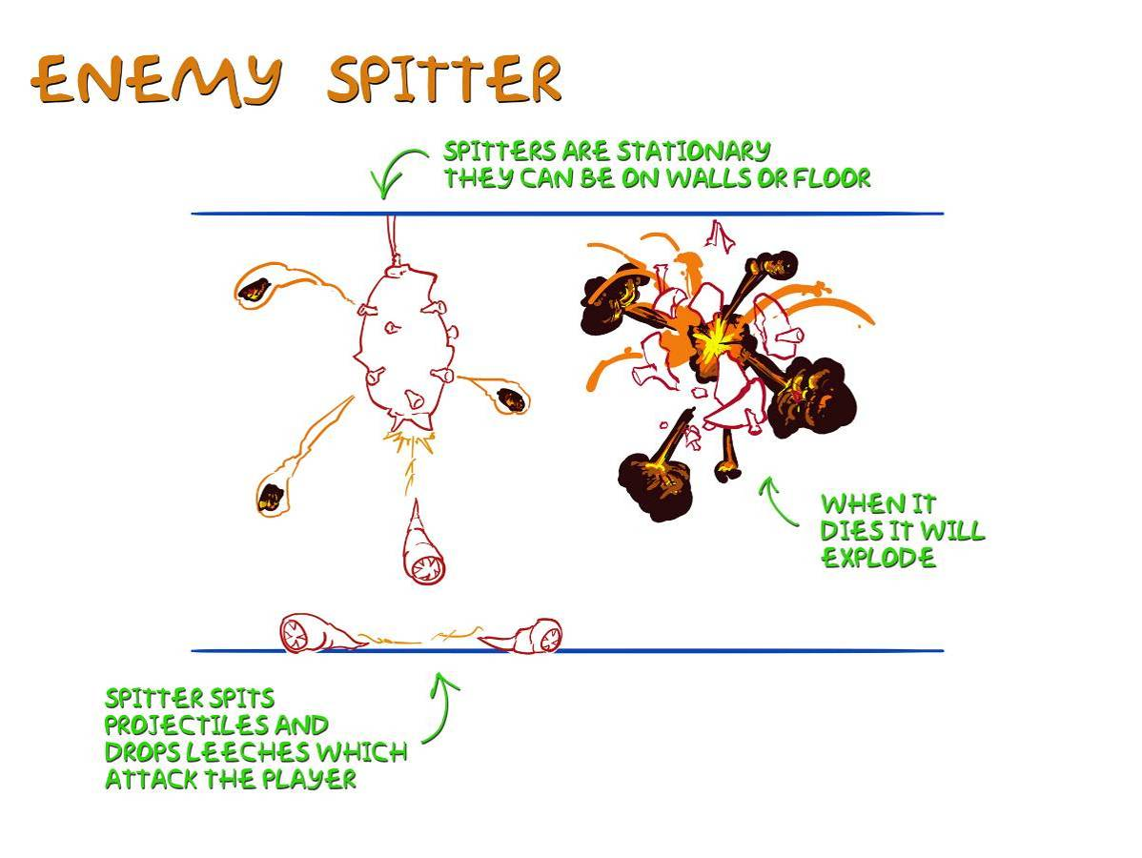

Description: The Spore enemy consists of 3 evolutionary forms. The first form of the Spore is the Spitter, a stationary creature that fires powerful projectiles. The Spitter typically situates itself in areas that are navigationally inaccessible to the player. The second form of the spore is the Leech, a small, worm-like creature which is occasionally spawned by the Spitter. The Leech can grow into the Spore’s third form, the Bloater, which acts as a walking bomb.

Spitter Abilities/Combat: The Spitter is a stationary enemy which hangs from ceilings. It fires Leeches, which will attack the player, latching on to them. The Spitter can be engaged in hand to hand combat but it will explode on contact. For Rick’s safety it must be dispatched with ranged attacks.

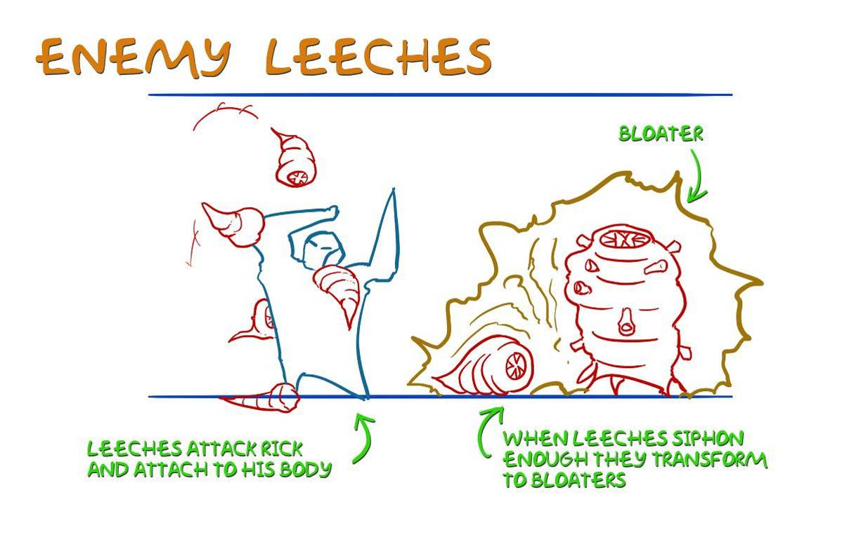

Leech Abilities/Combat: Leeches do not have any physical attacks: their sole goal is to attach themselves to Rick. Once attached, they cannot be removed. While attached to Rick, they siphon away his Necro, preventing the player from activating Berserker mode. They can even force him back into Brawler if he was already in Berserker. Once done feasting, the Leech will pop off of Rick and grow into a Bloater.

Bloater Abilities/Combat: The 3rd form of the Spore, the Bloater, acts as a walking bomb. It will attempt to get as close to Rick as possible and then detonate itself in a devastating explosion.

Each form of the Spore requires certain techniques from the player to destroy them. The Spitter needs to be destroyed from a distance by using projectiles. The Leech can be killed easily by any sort of attack as long as it has not attached to Rick. The Bloater can be dodged once it has gone into its explosion countdown animation.

Morlock
Description: The Morlock is a bestial enemy with ape-like agility and the unique ability to following Rick up onto combat jump nodes. They are not of the same “species” as other Corrupted, and are instead a race of para-dimensional mercenaries, serving as a kind of attack dog for the Corrupted. Their role in the Corrupted army can be compared to the Brutes of Halo 3 or the Kroot from the Warhammer games.

Abilities: The Morlock has the unique ability of being able leap in the air to attack Rick. Additionally, the Morlock can take Rick to the ground and initiate a dogpile sequence in which other Morlocks join the attack.

Combat: Other than their leaping attacks, Morlocks have a ground combat style defined by their bestial nature and their agility. They specialize in leaping/ramming attacks and agile movement.

Sub-Bosses
Sub-Boss encounters will be more difficult and grander than regular enemy encounters, but they are not made to be elaborate set-pieces like the full Bosses. Another important difference from regular Bosses is that Sub-Boss encounters can be repeated in later levels, whereas regular Bosses are so integrated with their environments that they can only be used once. However, these deadly creatures are far from generic, and will be unique and intense challenges for the player.

Aggressor
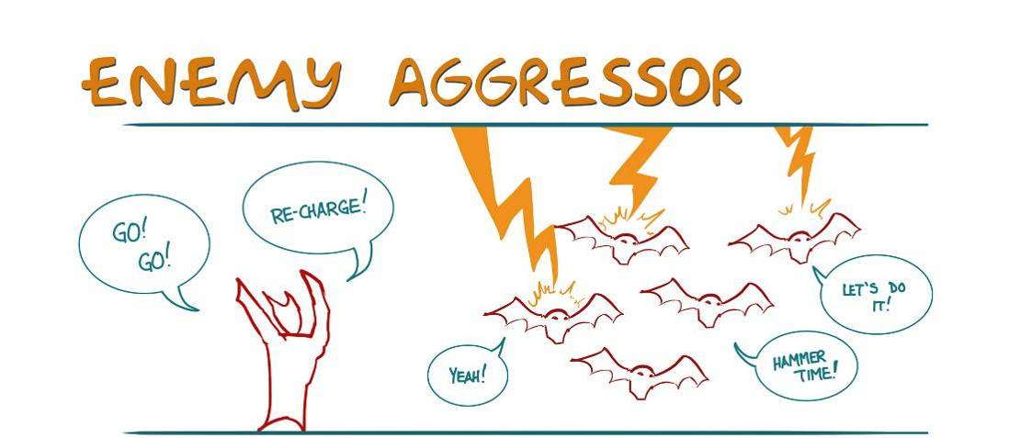

Aggressor are squad leaders of the Corrupted horde. His function is to rally his troops into a frenzy, making them faster and more powerful. However, if he is engaged, he is very capable of defending himself: in fact he is a much more powerful foe than his Foot Soldier underlings.

Summoner

One of the most powerful elements of the Corrupted Army, the Summoner’s purpose is to open up portals to the Corrupted realm, allowing waves of reinforcements to arrive. Each portal he opens will allow a limited number of enemies to come through before it collapses. He is vulnerable to projectile attacks, except when the magical shielding of his portal protects him.

Summary of Summoner Battle
- Theme: Kill a Summoner quickly before Rick becomes overwhelmed by enemy reinforcements.
- In most cases, a Summoner will appear and block an exit (surprising the player.) The Summoner will immediately summon a few enemies. After a short period, if the Summoner is still alive, he will summon a few more enemies. This cycle continues until the maximum number of enemies in an encounter is reached.
- The Summoner uses a beam attack against Rick. He uses a tracer beam for a few seconds and then fires a damaging beam.
- The Summoner counters all of Rick’s hand-to-hand attacks with a swipe of his tentacles.
- To defeat a Summoner, the player will need to hit him with a number of projectiles, causing the Summoner to become woozy, and then Splatterkill him.

Bosses
Enemy Name | Biggy Man | Manipede | Wickerman | Clawface | RoboApe | Mirror Rick | Furniture Boss | Thule Lord | Body Boss
Levels
Level 1 Act 3 Manor |  |  |  |  |  |  | X
Level 2 Act 1 Scottish Isle |  |  |  |  |  |  |  | X
Level 3 Act 1 Manor |  |  | X
Level 3 Act 2 Manor |  |  |  | X
Level 4 Act 2 Shanty | X
Level 5 Act 2 Manor |  |  | X
Level 5 Act 5 Manor |  | X |  | X
Level 6 Act 1 Carnival |  |  |  | X
Level 6 Act 3 Carnival |  |  |  |  |  | X
Level 8 Act 1 Arctic Base |  |  |  | X
Level 8 Act 2 Arctic Base |  |  |  |  | X
Level 9 Act 2 Manor | X
Level 9 Act 3 Manor |  |  |  |  |  |  |  |  | X
Player Able to
Splatterkill | X |  |  | X | X

Robo Ape
In the bowels of certain levels lurks a brutal and powerful creation, the Robo Ape. Fusing industrial power with bestial fury, the Robo Ape is more than a match for Rick’s physical strength. As if its massive size and bestial strength were not threatening enough, the Robo Ape can also use the powerful spinning blade that it has been biologically integrated with to deal incredible damage to Rick.

Summary of Robo Ape Battle
- Theme: Learn how to avoid RoboApe’s attacks, weaken him from a distance, and then damage him close up
- Encounter starts when Player jumps down off gantry
- Intro to RoboApe IGC: RoboApe enters the room, roars, cut to bomb activating, bomb begins to beep
- Beeping sound of bomb continues throughout battle, accelerating and increasing in volume during the last n seconds
- Each of the 3 glowing necro ‘lights’ on his chest will turn RED after each successful Splattermove/SK (they are his health indicator)
- Single travel nodes in each corner of the room are a temporary avoidance mechanism, so they need to time-out in a few seconds
- Phase 1: Roboape attacks using Swipe and Ground Pound
- Phase 2: Roboape adds the Jump Node attack
- Phase 3: Roboape adds the Ram attack
- The player must
1) Avoid RoboApe’s attacks…
  - Avoid Swipe Attack by dodge-rolling
  - Avoid Ground Pound by jumping (ground pound needs radius effect along the ground only – not in the air)
  - Avoid Jump Node attack by dodging or jumping to jump nodes
  - Avoid Ram attack by dodging or jumping to jump nodes
2) Damage RoboApe enough to make him woozy during each Phase by…
  - Hitting RoboApe with 3 charge stones, causing RoboApe to roar
  - During the roar, performing a breaknode attack (similar to Wman’s knees) on RoboApe’s exposed chest near the necro ‘lights’, causing him to become woozy
  - Performing a Splattermove (Phase 1 & 2) or Splatterkill (Phase 3)
3) Ending Cinema plays

Manipede
The sickening Manipede was created from the torsos of twisted humans. The Manipede moves along the walls on its hands in centipede-like fashion. It uses a long-range spit attack to damage Rick from a distance. Manipedes are susceptible only to projectile attacks.

Summary of Manipede Battle
- Theme: Avoid the projectiles that Manipede spits and attack him using your own projectiles.
- Phase 1: One Manipede on one wall; spits AOE necro bombs; player must do x amount of damage to Manipede by throwing projectiles to reach Phase 2.
- Phase 2: One Manipede on a different wall; spits multiple Leeches; player must do x amount of damage to Manipede by throwing projectiles to reach Phase 3.
- Phase 3: One Manipede moves to multiple walls; spits multiple Leeches that turn into Bloaters; player must do x amount of damage to Manipede by throwing projectiles to kill him.

Claw Face
What he lacks in the raw strength of the Robo Ape, Claw Face makes up for with his sadistic agility and razor sharp teeth. These are the spawn of the Corrupted ancient gods. The player will first be introduced to just one of these vicious monstrosities, but Rick may eventually have to contend with a multiple ones. These creatures will require Rick to use his most advanced combat techniques to break down and kill these tremendous adversaries.

Summary of Clawface Battle
- Theme: A fast and vicious attacker, the player must dodge Clawface’s razor sharp teeth and attack his vulnerable sides or counter-attack his tail and tongue attacks.
- Phase 1: Player must dodge Clawface's attacks and use the medium window of time between attacks to punch his sides; get him woozy; Splattermove him
- Phase 2: Clawface adds Tail Whip attack; window of time between attacks decreases; player can attack his sides or counter the tail attack n times to get him woozy; Splattermove him
- Phase 3: Clawface adds Tongue attack; window of time between attacks decreases; player can attack his sides or counter the tail and tongue attacks n times to get him woozy; Splatterkill him

Biggy Man
Atop the Slaughterhouse of Shantytown awaits the re-envisioned chainsaw-wielding enemy of the original Splatterhouse series. Biggy Man has chains attached to his chainsaws which will allow him to hurl the weapons toward Rick and then pull them back to his wrists. This gives him the capability of doing short, medium, and long range attacks. He can do quick jabbing and slicing attacks for close range, hurl the chainsaws around like some sort of whirling dervish for a medium range attack, or throw them forward to impale Rick and pull him into range for his short range attacks.

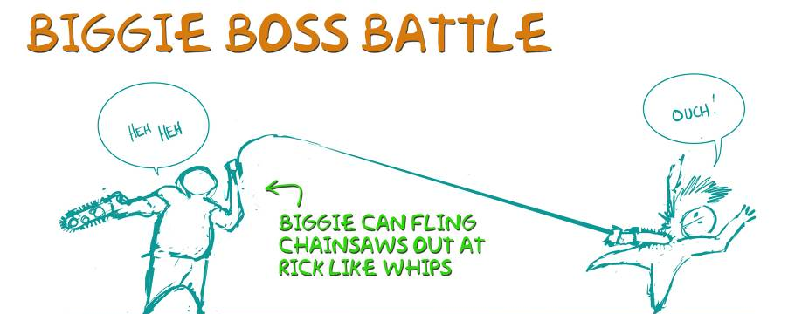

Rick will not be able to disarm Biggy to get his chainsaws away from him. Attempting to do so will cost Rick one of his own limbs and will make it clear that some other strategy must be found to defeat this nefarious antagonist. The battle with Biggie will take place around a damaged portal and the player will need to weaken Biggy enough to throw him into it – seemingly killing him.

Summary of Biggy Man Battle
- Theme: Close combat does not work; the player must first stun Biggie and then do opportunistic close attacks to damage him.
- Pattern: Avoid Biggie’s distance attacks; RAM him during a pause in his attack pattern (or shoot him 3 times with a Shotgun); punch/kick him while he’s stunned; get away before he recovers; SK him when he is woozy
- Biggie is either Active, Susceptible, Stunned, or Woozy
- When Biggie is Active…
    - Anytime Rick is near Biggie, Biggie will cut both of Rick’s arms off (or kill him if both arms are already gone)
    - Anytime Rick is mid-way toward Biggie, Biggie will use his spin attack
  - At all other times while Active, Biggie will use a recognizable pattern of distance attacks, with a pause somewhere in the pattern (Biggie is Susceptible during this moment)
  - Rick can use several (3?) shots from a shotgun to cause Biggie to be Stunned
- When Biggie is Susceptible, Rick can:
    - Use his RAM attack to cause Biggie to be Stunned
- When Biggie is Stunned, Rick can
    - Punch/Kick Biggie while he is stunned
    - Get away from Biggie before he recovers and becomes Active again
- When Biggie is Woozy, Rick can
    - Splatterkill him
- In the level there will be
    - Respawning necro powerups (a delay between re-spawns will make it harder)
    - Several re-spawning shotguns hidden under destructibles
- Biggie should have lots of health
- Biggie will have a taunt animation (Alt-Idle) to tell the player he is Susceptible
- Biggie will have a stunned animation (different from Woozy) and with a clear recovery (like shaking his head to clear the cobwebs) to tell the player to run away

Mirror Rick
In the ruins of an abandoned Carnival, there exists a mirror enchanted with Corrupted magic. This mirror will reflect a dark aspect of Rick’s personality and combat abilities whom Rick will need to defeat.

The encounter with Mirror Rick will occur in the House of Mirrors portion of the Fun House, in a climactic battle of the Carnival level. When the player first arrives he finds himself on a desolate platform whose perimeter walls are composed of a series of individual mirrors. A damaged portal sparks with energy in the middle of the platform. Suddenly, Mirror Rick materializes out of the mirrors and savagely attacks Rick. During the battle, the player will discover that he must move around the room, combating Mirror Rick while also attempting to shatter each of the unbroken mirrors. Special gilded mirrors in the corner require another technique. They can only be damaged by a ram attack from Mirror Rick. The player must taunt Mirror Rick into ramming him and dodge out of the way at the last minute. Once all the mirrors have been shattered, Mirror Rick can be killed and the now healthy portal in the center of the room draws Rick into it.

Summary of Mirror Rick Battle
- There are regular funhouse mirrors all around the perimeter of the level.
- There are 4 “special” ornate mirrors in the 4 corners of the mirror
- There is a jump node above each of the corner mirrors
- 4 Footsoldiers are always spawned and coming from the “regular” mirrors around the room
- The player can damage the regular mirrors by doing a couple of hits to them
- Footsoldiers can only spawn from unbroken mirrors
- If no mirrors remain unbroken, no footsoldiers spawn
- Mirror Rick spawns from any unbroken ornate mirror
- Mirror Rick pursues the player around the arena and attempts to attack the player
- The player can fight Mirror Rick like a normal enemy
- After he is killed, Mirror Rick respawns from any unbroken ornate mirror after a brief delay
- Mirror Rick will only use his charge attack if the player has knocked him down or he is attacking a normal mirror
- The mirror will need to send a message if a player hits it in berserker mode, telling Mirror Rick to charge at the player
- Mirror Rick can only be permanently killed by the player when all four corner mirrors have been destroyed
- The player needs to get MR to destroy the special mirrors at the corners of the room
- If Mirror Rick hits one of the corner mirrors in his charging attack, he will break the corner mirror
- There are jump nodes above the corner mirrors.
- If the player jumps out of the way at the last minute onto the jump node, Mirror Rick will smash into the corner mirror and destroy it
- If the player jumps too late he gets hit by Mirror Rick
- If the player jumps too soon, Mirror Rick will stop his charge and attack the player instead
- Once all four corner mirrors are destroyed, the player can defeat MR and he will die permanently
- When Mirror Rick dies the final time, he releases necro energy and it powers the portal, turning it blue so the player can leave

Large Bosses

Charge Stones
Before talking about the bosses themselves we feel it is important to highlight a gameplay mechanic that will be reused in many of the boss fights. Certain stones marked with ancient sigils will be placed in certain boss encounter environments. Without a catalyst to unlock their power, they are nothing more than a stationary stone. But when a stone is infused with necrotic energy, it glows with power.

If Rick throws the charged stone at a boss, it will have a special effect on that creature (these effects are listed in the individual boss sections below). Utilizing these stones properly will be the key to victory in Rick’s most epic encounters.

Charge Stones Fiction
Within the story of the game, charge stones are a key element to the arcane technology of the Corrupted horde. The charge stones are used as markers, placed by the retainers of the Corrupted lords, to demarcate Ley Lines and the nexus points where those lines crossed: places of power that they could use for their own nefarious purposes. It is at these locations that the Corrupted temples were eventually built. Besides marking the location of these places of power, the charge stones also act as sponges, soaking up the ambient energy that flows into these places of power. These stones are assembled according to ancient specifications at the core of the Corrupted temples to power the Corrupted Portals that Rick uses to teleport from the various levels to the mansion and vice versa.

Thule Lord
The Thule Lord, an ancient and monstrous tentacle beast, has hibernated undisturbed for centuries deep beneath the ocean waters nestled in a ring of desolate islands. Imprisoned there by mystical totems, it is allowed to surface to feed by a tribe Fish Folk who guarded over this earthbound Ancient God for millennia.

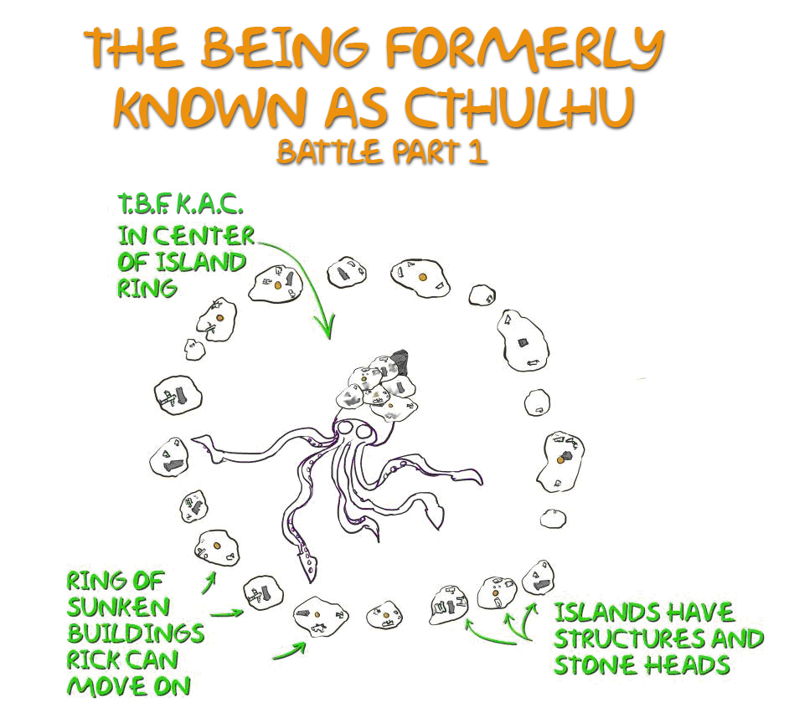

When Rick arrives at the archipelago, the Thule Lord is submerged in the bay, subdued by the machinations of his captors. The Fish Folk kept him under control with megalithic stone statues: their gaze keeps the humungous beast docile and slumbering. Rick’s first task is to overwhelm the Fish Folk and Corrupted forces and deactivate the stone guardians on each island by turning their gaze away from the Thule Lord.

As Rick rotates the last of the statues, the Thule Lord, enraged from centuries of captivity, erupts from the sea, ready to feed and instilling mortal fear in the Corrupted horde. What Rick can see of this gargantuan creature is just his massively tentacle carapace head, a head that has been encrusted with century’s worth of barnacles. In the center of his head, almost completely encased in organic residue is a huge charge stone.

In his frenzy, the Thule Lord begins to wildly attack his surroundings, hurling bombs toward Rick, shattering on impact. The Thule Lord also fires deadly beams of eldritch energy across great distances to pulverize structures.

As the savage beast unleashes its assault, the connecting bridge ways between islands are turned into nothing more than rubble. Rick is now forced to leap between the crumbling ruins of the bridges to gain access to the other islands this second time around. On each island Rick must draw the Thule Lord’s beam or bomb attack near the island head, destroying the head and revealing the source of its power – a charge stone. Each charge stone must be thrown at the beast, damaging him.

When Rick is down to the last island, throwing the last charge stone will unleash a massive blast of eldritch energy that dispatches the colossal Thule Lord. The behemoth’s death triggers the activation of the islands ancient portal and Rick is once again hurled through space and time to the mansion.

Summary of Thule Lord Battle
- By default, the heads will be FACING the Thule Lord, with the beams ON (ie. keeping him at bay)
- The player will turn each head, turning the beams OFF, ultimately releasing the Thule Lord
- The Thule Lord will destroy the first head via a beam or bomb attack. A charge stone will be revealed in the debris.
- The player will then throw the Charge Stone at the Thule Lord to damage him
- When the Thule Lord is damaged, we will show visible damage on him from each hit so the player can see the boss’s ‘health’ getting lower.
- On each successive island, the player must lure the Thule Lord’s attack at the island head to destroy it and reveal the charge stone.
- The final thrown charge stone hits the Thule Lord in the crown/pearl, exploding and breaking it open. Cut to cinematic. Light will be emanating out of the broken pearl, as the portal starts forming above the Thule Lord’s head. The Thule Lord will be writhing in pain, and slowly sink into the water as the portal continues to grow.

The Wickerman, Furniture & Body Boss Type
We grouped together the Wickerman, Furniture Boss, and Body Boss into one boss type because they share similar mechanics and technical requirements. The gameplay for these bosses overlap because they all share the same general scale and similar combat mechanics.

Furniture Boss
As a precursor to the Furniture Boss himself, the player will first encounter Poltergeists - chairs, battle axes, bookshelves etc. will rise into the air and attack Rick. Rick’s only recourse against this flying enemy is a well-timed dodge, causing the furniture piece to impact the floor and be destroyed.

Summary of Poltergeist Battle
- The intent of poltergeist is to teach blocking and dodging (The ability for Rick to double-jump and attack the poltergeist has been removed.)
- Poltergeists will attack Rick by flying at him. They can hit him to cause full damage, Rick can block (only takes half damage), or Rick can dodge and the poltergeist hits the ground. In all cases the poltergeist is destroyed.
- Phase 1 of the battle: Single pieces of furniture fly at Rick
- Phase 2 allows sequences of furniture attacks (ie. requiring the player to block or dodge multiple times). Phase 2 might be most easily accomplished by having two pieces of furniture in close proximity (so that the camera sees both of them)
- The camera needs to show the attacker(s) and Rick

While exploring the West Manor, the player will enter a particularly large and well appointed room: a vast and elegant receiving hall populated from wall to wall with furniture and objet d’art. When Rick enters the room, the doors will slam and more poltergeists will come to life, throwing themselves at Rick: he will need to bat the pieces away or dodge them. After a certain amount of time, the pieces of furniture and left over debris will assemble itself into a towering humanoid figure.

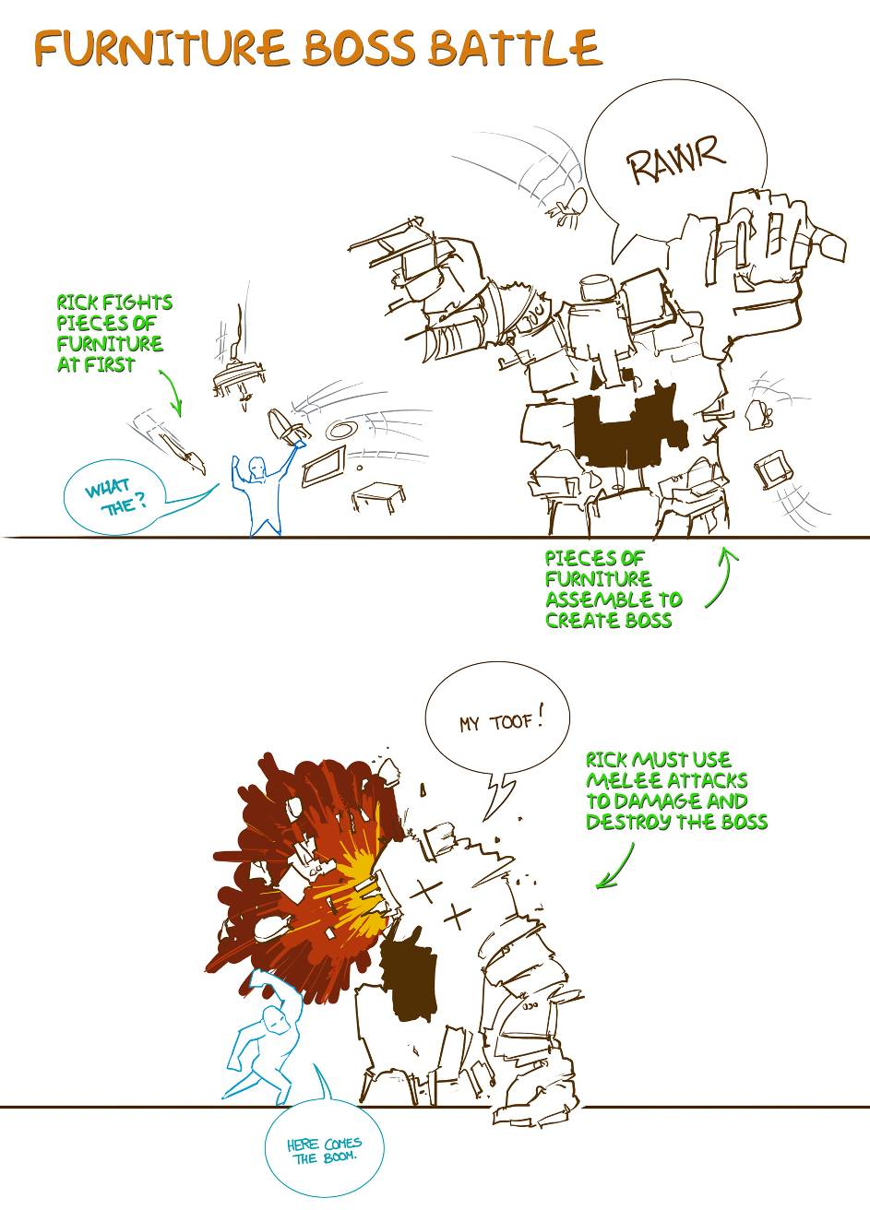

The furniture boss will have melee attacks, including horizontal sweeps, vertical slams, and vicious stomping barrages. Rick must destroy it by smashing it to splinters.

Summary of Furniture Boss Battle
- Theme: Utilizing the break nodes and the Ram attack that have been taught to the player in level 1.
- Encounter starts after the player finishes fighting the Poltergeists
- Stage 1 attacks: Foot Stomp (Medium AOE around the foot) and Throw (Thrown Furniture at the player)
- Stage 2 attacks: Add Ground Pound (Large AOE)
- Stage 3 attacks: Add Summon Furniture (Flying Furniture)
- The player will have to do the following
  - Get in close and dodge the thrown furniture and foot stomps.
  - Jump up to each knees break node
  - After each break node is successfully hit, Furniture Boss will go into a teetering/woozy animation. We will put a rim light on one of the Furniture Bosses legs and the player will need to use his Ram attack to hit the leg.
  - If the player successfully hits the leg with the Ram attack, then the Furniture Boss will fall over and break apart. If the player fails to hit the leg in a certain amount of time then his knee will reset.
- After the player has successfully knocked over the Furniture Boss, we will resume another round of poltergeists attacking the player.
- When the player has destroyed the poltergeists, then the Furniture Boss will reform.
- After knocking down the Furniture Boss twice, and the player has successfully hit both knees we will cut to a canned scene of the Furniture Boss trying to stomp on Rick, and Rick doing the stomp counter on him, throwing him backwards and having him shatter into pieces. This will be the foreshadowing of what the player will need to do for the Wickerman which he will encounter a couple of levels later.

Wickerman
Rick will first encounter a Wickerman in the Mansion Gardens. The Corrupted hordes responsible for building the Wickerman make their anger known and attack Rick along with the Wickerman. The Wicker Man has melee attacks, including a sweeping attack, a ground smash, and a foot stomp. In addition, it can throw a mass of timber, hay, and flesh at Rick.

Rick must search the courtyard for something to kill the Wickerman with. He will find that a combination of Charge Stones, leaping attacks and jumping upon his dazed foe will be sufficient to bring him down.

Summary of Wickerman Battle
• At the beginning of the encounter, the necro released from zombies that you kill will fly toward and be absorbed by Wickerman, not the player
• When all zombies are killed, the player’s necro will be sucked out of him and fly toward and be absorbed by Wickerman, causing Wickerman to come to life
- The player must perform glancing blows to the Wickerman’s knees, which causes him to use his stomp attack.
• The player must now destroy the Wman’s knees. This is done by countering his stomp attack (holding block beneath his foot stomp) and then attacking his knees via a minigame.
• Destroying each knee gives the player ½ skull of necro
• When both knees are destroyed, zombies spawn (an infinite amount – they are there in case the player needs more necro)
• The player must hit Wman with 2 charge stones to kill him. The first stone catches Wman on fire and he becomes faster and more aggressive. The second stone kills him.

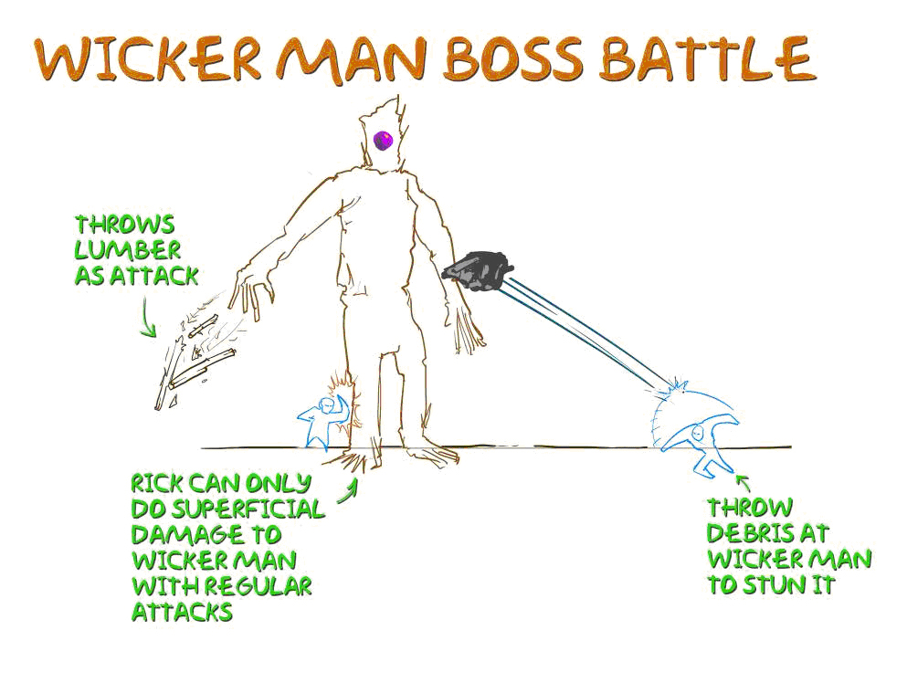

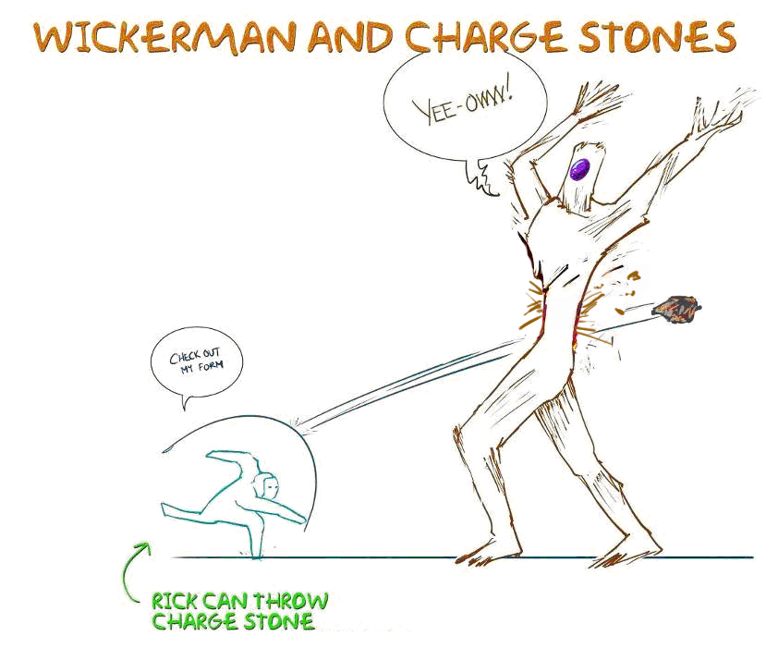

Body Boss
The player will encounter the Body Boss as the final boss in Splatterhouse. The encounter will take place in previous hidden part of the mansion ground in an enclosed area with an ancient ruin. At the ruins, Corrupted forces led by Dr. West have begun an ancient ritual, summoning the Corrupted Overlord, a being of tremendous power.

The Overlord uses his tremendous power to reanimate the previously killed (by Rick) enemies. Bodies fly from the various parts of the mansion estate and energy surges out of the vortex into the stream of corpses. They dead bodies rally, assembling themselves into one being: a mangled mass of bodies and limbs to serve as the host for the Corrupted lord.

The Body Boss attacks by stomping on the player with its feet and by swiping with its large arms. In addition to these melee attacks the Body Boss also has the ability to hurl bodies at the player which will then rise up as zombies and attack the player.

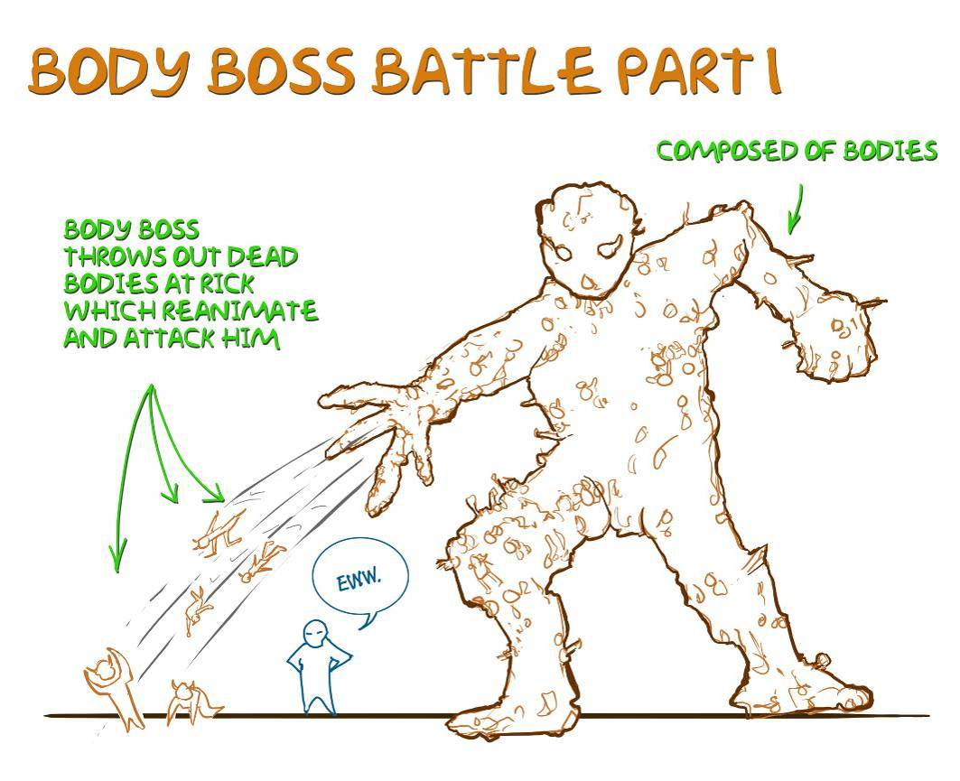

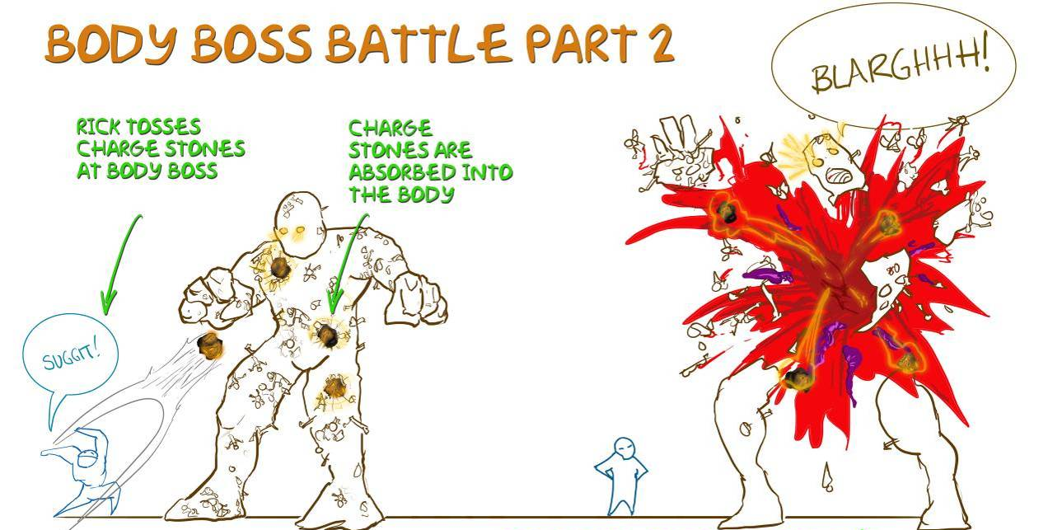

The player must defeat the zombies thrown by BB to generate enough necro to fill super charge stone (requires more necro than usual) The player must fill 3 charge stones, then throw them at BB to stun him. The player must then use jump nodes to reach an outer island and fire an island head at BB. The BB recovers after a few seconds. The player must then repeat this sequence using stones to stun the BB, use a second island head, and fire it to destroy the BB. The Body Boss destruction will cause a tremendous backlash of energy producing a prodigious discharge obliterating the Body Boss and rending apart the spectral energy of the Overlord.

Enemy Generation
Enemies are generated in three different ways: placement, Summoners/Sentinels, and mini-portals. Placed enemies exist in the level when the game starts. These enemies can be on patrol or in various idle animations, but they are already there when a player comes upon them. Enemies can also be generated by a Summoner or Sentinel, who have the ability to open portals to generate more enemies. Sometimes enemies will emerge through mini portals, which can spontaneously appear at any time. Mini portals allow us to create waves of enemies and “surprise” encounters that will startle the player.

User Interface

Menus
The following is the flowchart for the front end menus:
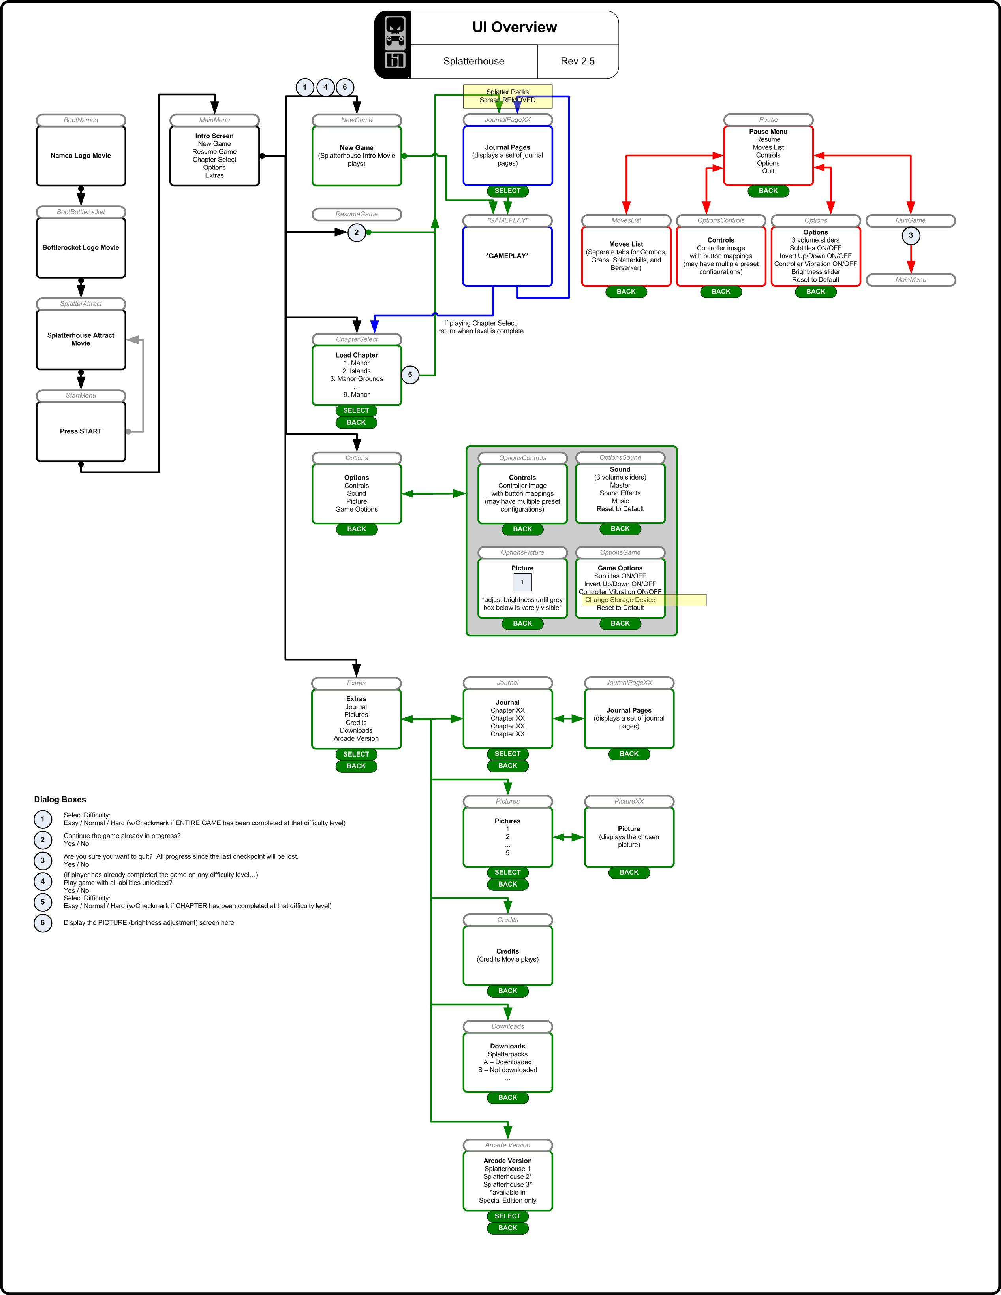

HUD

Philosophy
Bottlerocket’s philosophy regarding user interfaces, especially HUD’s, is to keep them to a minimum, as they tend to obstruct the player’s view of the world of the game, and disrupt its sense of immersion. At the same time, however, we are keenly aware of the importance of clearly and effectively communicating essential information to the player. By striking a balance between these two goals, we can communicate information elegantly and effectively.

To more fully integrate HUD information with the virtual space of the game, HUD elements will be placed within the game environment whenever possible. For instance, elements of Rick’s status, such as his health, can be displayed on his actual person, so that the player’s immersion into the game world is not obstructed by a health bar arbitrarily floating on the camera plane.

The game’s HUD will have to communicate the following information to the player:

- Necro energy capacity
- When the player can activate Berserker mode
- How long Berserker mode will last when activated

Levels

General Level Format
Most of the levels of Splatterhouse are essentially linear experiences. Although there may be some backtracking, it will always be in a controlled and planned way, and there are no branching paths.

Environments
Please note that although these walkthroughs provide high level overviews of the elements of a given level, changing gameplay and development considerations may trigger adjustments to the specific flow of each level. The most current level information will be provided in the form of separated level documentation, flowcharts, and maps. However, all levels will be developed within the framework outlined below.

Level Walkthroughs
This is a simple overview of the progression through the game levels. Rick will be traveling through various parts of the manor interior and its estate in order to reach the mansion’s central portal. Entering the portal sends Rick to a different environment where he must battle through hordes of enemies to follow the trail of Dr. West and Jennifer. Every time he returns to the mansion, he arrives somewhere different and has to work his way back to the central portal in order to access the next area and continue his search. Rick must make his way through all game levels to confront Dr. West and rescue Jennifer.

Level 1: Mansion
- After the cinematic intro of the game, the player finds himself in the West Wing of the manor. He will battle through the mansion on the trail of Dr. West and Jennifer.
- Dr. West will run into the lower storage room and before Rick can follow he will be assaulted by flying furniture.
- The furniture eventually turns into the Furniture Boss and the player will need to defeat it before he can go into the portal room (see Boss Section for more detail)
- Once in the portal room, the gateway is open, and Dr. West jumps through with Jennifer. With no other option available, Rick decides to follow. He leaps into the portal and is sucked into the vortex.
- The player will find himself on the beach of the Thule Isles…

Level 2: Thule Islands
- The player will be introduced to the monolithic Easter Island heads and the Corrupted influence on the submerged cities natives.
  - There will be run down structures.
  - There will be bridges running between many of the islands.
- The player will be instructed by the mask that in order to awaken the Thule Lord, he will need to rotate all the heads 180 degrees.
- This leads the player around the islands doing various combat scenarios defeating the corrupted island natives guarding the heads.
- Once he has managed to turn all the heads, a central ‘island’ with a huge charge stone embedded into its cliff face will rise out of the bay and keep rising to reveal that it is the crustaceous head of an ancient god, the Thule Lord.
  - The mask will have forgotten to mention that tiny detail.
- The Thule Lord fires bomb and beam attacks, crashing into and destroying the various structures and bridges.
  - Bridges that get destroyed will leave behind jump node paths for the player to navigate.
- As the player circumnavigates the islands, he charges heads and fires beams at the Thule Lord. Once fired each statue head is destroyed.
- Upon firing the last statue head the player triggers a massive explosion that will take out the Thule Lord and create a portal to take Rick out of the area.

Level 3: Mansion
- When the player arrives back at the mansion, he finds himself outside in the Manor Gardens.
- The player will battle the Corrupted on his way back to the mansion.
- As the player starts killing Corrupted he encounter his first Wickerman.
- After defeating the giant Wickerman. the player will enter the mansion and explore new areas on his way to the portal room.
- Reaching the portal room, Rick discovers an inactive portal surrounded by portal charge stones. Rick must battle waves of enemies to collect enough Necro to charge the stones. Once charged, the portal activates and Rick jumps in.
- The player is teleported to the Shantytown / Slaugherhouse level.

Level 4: Slaughterhouse
- The player arrives on the outskirts of a shantytown and must defeat the Corrupted that have taken up residence there, as well as smashing through shanties.
- The player will be introduced to the innocents, a para-dimensional race who are being slaughtered by the Corrupted horde, snatched from their homes by Morlocks.
- The battle will continue to rage down through the town, with shanties being destroyed left and right in the chaos.
- The player’s journey through the Shantytown will end at the Slaugherhouse factory.
- Once inside the Slaughterhouse, the player will have combat encounters with Corrupted. The player sees the innocents going through various stages of processing.
- On the top floor, the player will encounter Biggy Man.
- The battle will culminate with Biggie Man being knocked into a broken portal.
- As the evil energy subsides, the portal returns to normal. Rick jumps in and is teleported back to the mansion.

Level 5: Mansion
- When the player arrives back at the mansion, he finds himself outside in the Manor Courtyards/graveyards.
- The player will battle the Corrupted on his way back to the mansion.
- The player is attacked by multiple Wickermen and must defeat them.
- Entering the mansion, the player will explore new areas of the manor on his way toward the portal room.
- Prior to the portal room, the player will have to face and defeat the Manipede.
- Reaching the portal room, Rick discovers an inactive portal surrounded by portal charge stones. Rick must battle waves of enemies to collect enough Necro to charge the stones. Once charged, the portal activates and Rick jumps in.
- Accessing the portal teleports him to the Carnival.

Level 6: Carnival

Midway Games
- The player starts off the level by traveling through the midway games area of the carnival.
- The place will be shrouded with fog and the player will just barely be able to make out a Ferris wheel at the end of the midway.
- Rick will have to overcome his fear of clowns and fight his way through all carnival sections to reach the Ferris wheel area.

Ferris Wheel
- Rick’s eventual goal is the portal room that is hidden inside the Fun house, but he must find a way to get inside.
- Arriving at the Ferris wheel, Rick must engage in combat to allow him passage towards the FunHouse.

Fun House
- The fun house is a large arena, with a platform ringed by mirrors.
- This is where the player will encounter Mirror Rick
- Combat with Mirror Rick and with other enemies will allow Rick to build up Necro and transform into Berserker mode.
  - This then allows Rick to either go toe to toe with his evil twin, or use his time to destroy the mirrors.
- Once all of the perimeter mirrors are destroyed Mirror Rick will be defeated.
- The portal in the center of the platform will activate and draw Rick into it.

Level 7: Arctic Base
- The player will arrive on the first floor of a dilapidated military base.
- The player will have to work his way through each floor to locate a staircase to a lower floor.
- This pattern continues until the player reaches the control room of the deepest floor.
- There the player must defeat the RoboApe boss
- Finally, the player must activate a portal to return to the Manor.

Level 8: Final Mansion Return and Body Boss
- The player arrives in the graveyard area of the estate
- He must defeat Biggy Man before he can proceed to the nearby peninsula in search of Jennifer.
- Dr. West is about to summon the Corrupted Lords to this plane of existence.

Body Boss
- Dr. West is situated in the mansion grounds peninsula with Jennifer. They are surrounded by swirling eldritch energy
- A ceremony has started in which Jennifer will be sacrificed.
- Rick interrupts the ceremony which triggers the activation of the Body Boss.
  - Bodies will start to rise up from the ground and collect together into the Body Boss.
- Rick will need to defeat the giant Body Boss.
- Rick is now free to save Jennifer.

Musical Score and Sound Effects

Sound Effects
Although the exact list of sound effects that will be required throughout the game will be in continual development based on the input of our creative directors and our sound engineer, in this section the goals and highest priorities of the game’s sound effects will be outlined.

Combat Sound
The sound design for combat related sounds will be of utmost importance. Much of Rick’s character is expressed through his combat abilities, and to truly bring that character to life will require careful and robust sound design. Bottlerocket takes an expressive approach to delivering gameplay, and the “fourth dimension” of the game will be leveraged appropriately.

To deliver our vision of wet, messy, fleshy combat will require that the sound design synergizes flawlessly with character models and particle effects in order to resonate with the player. Wet impacts, brutal crunches, and the deliciously repulsive squelches and gurgles of thoroughly pulverized bio matter will be the main focus of our combat sound design.

Environmental Sound
The main focus of our environmental sound design will be on ambient sound and environmental destruction. Sound will be key to fully realizing the game’s environmental destruction and bringing it to life, which is in turn a key element in demonstrating Rick’s brutal character. The crunch of rubble, the hiss of settling dust, and having a realistic sound associated with each material will be of particular importance to the game.

Ambient sound will be instrumental in establishing the game’s atmosphere. The focus will be to creatively design sounds that engender a general sense of discomfort and malaise, especially throughout the more quiet, suspenseful sections of the game. The kind of ambient sound design we are aiming for is especially prevalent in the Silent Hill games.

Music
Overview
The musical design of Splatterhouse is intended to create player immersion in two specific areas. The first of these design goals is the player’s feeling of uneasiness. We are aiming for the player to feel uncomfortable and “on edge” throughout the course of the game - specifically in areas where the player will be out of combat. This goal will be achieved through the use of ambient music. Ambient music will draw upon an industrial feel and the work of artists like Mastadon, The Sword, and Nine Inch Nails.

The second musical design goal is focused on contributing to the intense excitement of action oriented parts of the game, such as combat and boss fights. The combat music will draw upon a blend of deathmetal and grindcore. If possible, we’d like to license music from active bands to add even more flavor and authenticity to the combat music and really drive home the aggressive, no-holds-barred feeling we want to deliver to players.

Music will also be used during cinematics. The design goals of the cinematic music are dependant on the context of the cinematics. Cinematic music will range from being orchestral, which will fit in with player expectations based on their experience with films, to a more hardcore, driving musical arrangement to enhance the story being told through the specific cinematics.

Areas being considered for music
- User Interface (UI)
- Main Menu
- Pause Menu
- Credits
- Ambient
- Per Level
- Significant Moments
- Combat
- Boss Fights
- Rick
- On Death
- Brawler
- Berserker
- Cinematics

Delivery Systems
The game will make use of a music delivery system similar to previous Bottlerocket titles. For example, significant encounters and cinemas will trigger a transition from exploration music to appropriate scores. We intend this triggering to appear as seamless as possible in order to keep the mood immersive.

Triggering can occur in a variety of ways. Some examples are listed below:
- Entrance of an enemy
- Cinematic moment
- Player activation of a device
- Boss Battle
- Level start or finish
- Combat
- Discovery (item, secret, passage)

To achieve this functionality, our music will have to be composed following specific guidelines. Specifically, it will have to be composed in pieces that can be procedurally layered together depending on the context of the player’s activities.

For example, when the player is wandering around, a base ambient track will be playing. This base ambient track is actually composed of several pieces, orchestrated to play at specific intervals and in pre-determined combinations. The result is non-looping ambient music that can play for an extended period without becoming repetitive or tiresome. When an enemy becomes aware of the player, it would trigger additional musical elements to layer on top of the already playing base track. As the combat elevated in scale, even more layers would be added into the sound, such as drums, driving guitar riffs etc. to mirror the excitement of the combat. When combat was over, the music layers would fade out and the soundtrack would return to its base ambient layers.

Ideally, these musical layers will provide us with a lot of flexibility in mixing and matching musical elements to provide a soundtrack that is not monotonous and repetitive, transitions between exploration and combat, and provides a high degree of customization.

Using Licensed Music
To appeal to our audience, licensed music will be used during specific boss battles. The music will cycle from song to song if the battle lasts longer than any given track.

Cinematics
This section is a listing of the in game cinematics currently planned for the game. This list may change due to a myriad of load considerations, gameplay tuning, and focus testing. Simple ‘scary moments’ (camera cuts, enemy introductions, etc.) are listed in separate pacing charts for each level.

Name | Description | Duration | Realtime /BINK
L1A3WestEsc | DW escapes w/ JF | 1:05:00 | BINK
L2A1Intro | Islands Intro | 0:46:00 | Realtime
L2A1Outro | Cthulu death, outro | 0:35:07 | BINK
L3A1Intro | Manor Intro | 0:43:00 | Realtime
L3A1Secret | Secret Entrance after Wickerbattle. | 0:30:00 | Realtime
L3A2Lobby | Lobby Intro | 0:21:00 | Realtime
L4A1Intro | Shanty Intro | 0:40:00 | Realtime
L4A1ShEnter | Slaughterhouse Enter | 0:19:00 | Realtime
L4A2Intro | Slaughterhouse Intro | 0:12:00 | Realtime
L4A2Elevator | Elevator gag | 0:21:00 | Realtime
L4A2Biggie | Biggie Intro | 0:50:00 | Realtime
L4A2BiggieDie | Death of Biggie, outro | 0:21:00 | Realtime
L5A1Intro | Intro  Rick is on cliff edge--Wickerman stomps to break hole in wall/cliff edge jump-off. | 0:18:00 | Realtime
L5A1Secret | Secret Entrance in graveyard. |  | Realtime
L5A2Lobby | Lobby Intro | 0:21:00 | Realtime
L6A1Intro | Carnival intro | 0:30:00 | Realtime
L6A2Mirror | Mirror Rick Intro | 0:37:10 | BINK
L8A1Intro | Intro to arctic base | 0:30:00 | Realtime
L8A2Outro | Outro  Rick jumps thru window to portal to avoid bomb explosion. | 0:48:00 | BINK
L9A1Intro | DW/JF sacrifice, RB lands | 1:10:28 | BINK
PortalCommon | Short PORTAL close seq. | 0:08:00

Conclusion
We at Bottlerocket are confident our take on the Splatterhouse franchise will be a fresh and innovative re-envisioning of a classic game that will bring it to the forefront of the next generation of gaming. By modifying Splatterhouse with new and unique features and exotic portal levels we will take the game beyond its arcade roots and into the level of richness and complexity the next generation of gamers expects. By deepening the game’s signature elements with extreme gore, dismemberment, messy regeneration, and Rick’s new combat modes we will satisfy fans of the franchise as well as emphasize the appeal that made the original game a classic.



